61-000

1 he Official Publication of ALOA—An International Association of Security Professionals

*i:*****************2_j)jQ]T 303

Look Inside the Latest and Greatest!

With: Videx Cyberlock, Master's Street Cuff  
and Select Access, American's new 2500 padlock.

Breck H. Camp CML PO Box 47070 Atlanta GA 30362-0070

Plus: Ford's F-1 50 Transponder, a really tough gun safe, and more.

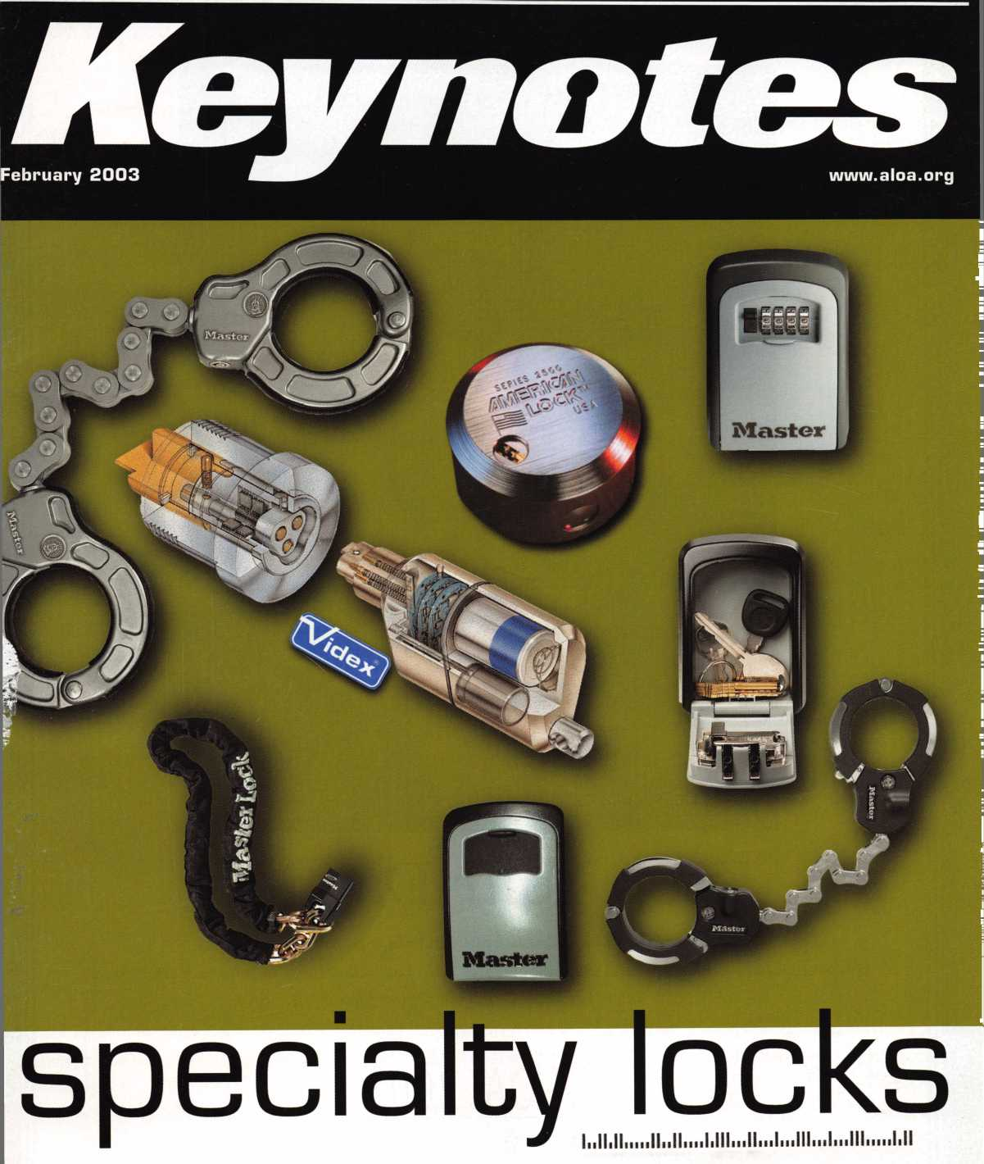

Keep Your Day Job

Come to Las Vegas and invest in your future as a security professional.

Discover classes, workshops, and exhibits that will keep you competitive in today’s marketplace.  
Las Vegas Hilton/Las Vegas Convention Center • July 14-20, 2003

The only gamble is staying home

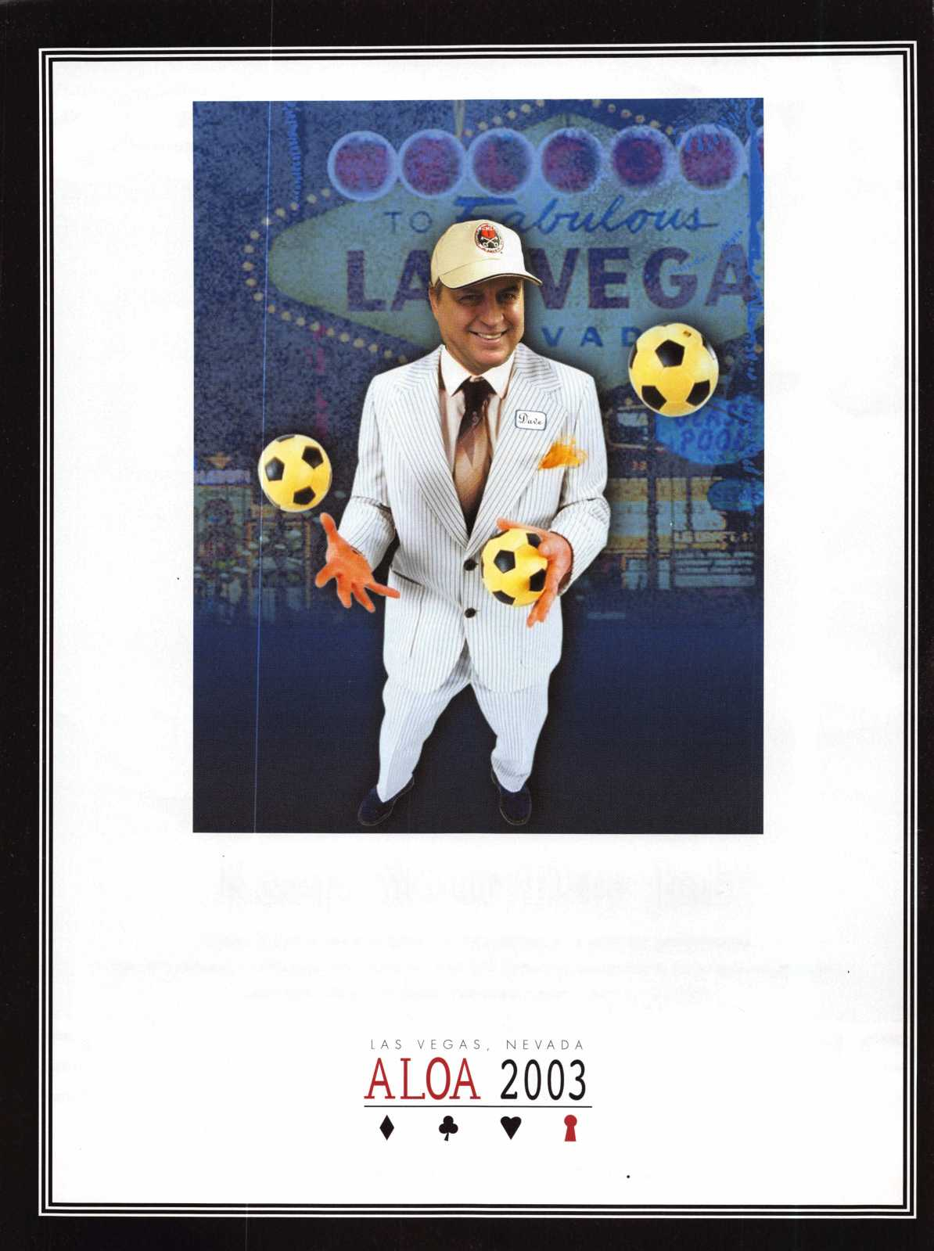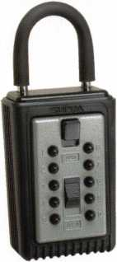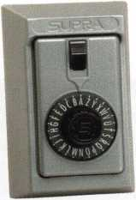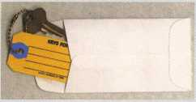

ANDOVER LOCK & KEY SERVICE

3221 LAKESIDE HWY.  
ANDOVER MA 05242  
(508) 628-1111

f V-Oc’s~a<-u^s

**\*$7.00 SHIPPING CHARGE ADDED PER ORDER** NY RESIDENTS ADD APPLICABLE SALES TAX

**SANZO SPECIALTIES, INC. BOX 68 ENDICOTT, NY 13760 TOLL FREE: 1-800-222-4041 FAX: 607-748-0507**

**COMBINATION KEY BOXES**

©SUPRA

**ALL METAL**

**PROFESSIONAL**

**SERIES LOCK BOXES**

Key Storage Lock Box

t/ALL METAL Construction

* Great Economical Pricing
* Simple to set/ Simple to open
* 5 Year Warranty

Both models now have weather resistant ALL TITANIUM METAL CONSTRUCTION with metal back and buttons. Both models are also available with PUSH BUTTON COMBINA TION LOCKS that are easy to set & reset.

Stock # C3-PUSHBUTT0N

Removable KeyBox, DoorGuar rubber bumper protects surfaces

Stock #C3-DIAL

Removable KeyBox  
DoorGuard rubber bumper protects surfaces

**DIAL**

**PUSHBUTTON**

1-4 37.95 EA. / 5-9 34.95 EA.

10 or MORE 31.95 EA.

No Home Should Be Without One  
The Surface-Mount S-5 Supra  
Lockbox is a product you can provide to  
any homeowner, easily priced to your  
customer in the $50.00 range installed  
(simple 4 screw installation). Carry one

with you at all times to demonstrate - Stock # S5-PUSHBUTT0N  
once shown it sells itself!! Surface Mount Unit

1-4 36.95 EA. / 5-9 33.95  
10 or MORE 30.95 EA.

Stock #S5-DIAL

Surface Mount Unit

ShurLok has designed an all-metal key storage box that is the safest, most secure lock box on the market. Separate easy to set combinations open the shackle and key compartment — and the combinations can be changed in seconds. The ShurLok is so simple to use a child can open it, yet so versatile it will satisfy the Real Estate professional or anyone requiring key access in a lock box. Unique double combination allows all users access to key(s) while allowing only authorized users access to the shackle and will prevent lock box removal or theft.

**1 to 9 $19.95 ea.**

**10 or more $17.95 ea.**

*if color is not specified we ship blue*

Stock #SLK100R

Brick Red

**AD / ID KEY TAGS**

Specifically designed to identify the product you work with  
daily and promote your business with your custom Ad copy.

back side of tag with 4 lines for key identification

**Clear Plastic Protective Sleeves** Stock# PPS10

Protect your key tags with  
durable plastic sleeves

**Key Tag Envelopes**

Stock # KTE3 Actual Size: 2Vzn x 4V4n Added security and finishing touch when presenting keys to your customers

* 100 200 500 1000

10.50 17.00 37.50 65.00

it 100 200 500 1000

11.50 19.95 42.00 68.50

**TO ORDER:** Choose QTY., Key Tags with Chains or Rings, TAG COLOR and Provide Imprint Copy (printed black only).

QUANTITIES

**FREE Printing**

**of Your Ad**

**Copy on bac**

LAKEVIEW

LOCKSMITH

24 Hour Service **(845) 556-LOCK**

Choose from Brass Plated Bead Chains or Chrome Plated Wire Rings

1000

2000

3000

5000

**it** KEY TAGS with CHAINS or RINGS 32.00 42.95 83.95 115.00

YOUR CHOICE OF CHAINS OR RINGS - IF NOT SPECIFIED WE SHIP CHAINS

195.00 269.00 395.00

Key Tags Only (no chains or rings) - Deduct 10% from above prices

National Logos - No Charge / Custom Logos - Add $25.00 and supply clean B & W artwork

Set your own combination

The combination can be changed in seconds —  
without special tools or disassembly. Changing  
the shackle combination also automatically changes  
the combination for the sliding key storage door.

**10,000**

huttnn **Combinations**

^ **Possible!**

chan9e

|  |  |
| --- | --- |
| 11(111!) |  |
| 1 " 1 | , (D |

Changing the combination

for the shackle  
. only takes a few seconds  
S with a simple turn  
of the change button.

**froducts locksmith Professionals**

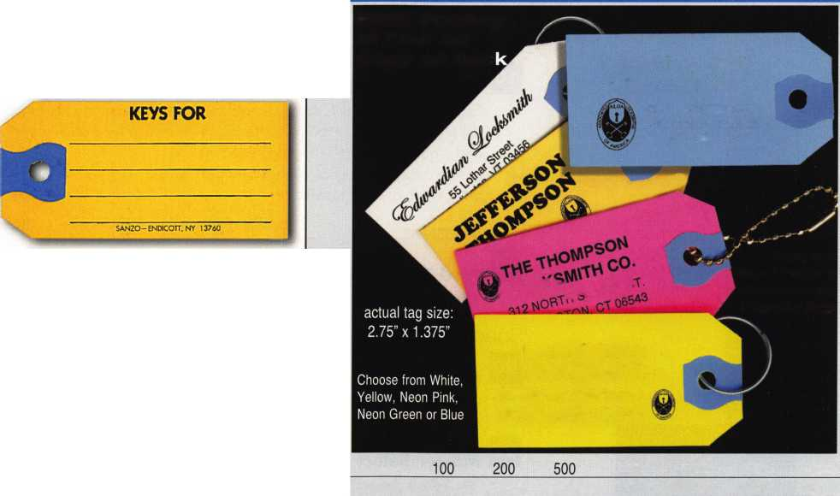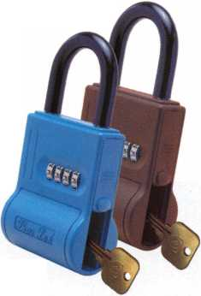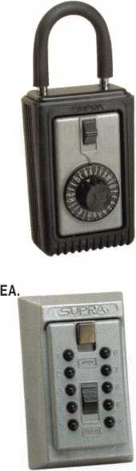

f

e

a

t

u

**res**

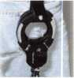

Specialty Locks—Access Control

Videx - CyberLock, Part 2 By Sal Dulcamaro, CML

Since the heart of the CyberLock system is centered around an electronically- enhanced mechanical lock cylinder, it can be installed just about anywhere, and it goes into virtually anything that uses an ordinary mechanical lock cylinder; a place where few other brands or systems can follow.

Automotive:

Ford Tough: Harley F-150 Sports **Transponders^ MTnpanier,RL**

Its a match made in heaven with some interesting curiosities.

**16**

10

Specialty Locks:

**20**

**22**

**24**

Master Street Cuff By Billy Edwards, CML

New from Master, the Street Cuff is a high security bicycle and motorcycle lock designed to be lightweight and easy to use.

Master Select Access ByBUiy Edwards, cml

The 5400D from Master has the appearance of a large padlock, and the shackle may be used to lock it onto a doorknob, a post, etc. The 5401 D wall- mountable version is larger.

A New Round Body By Greg Perry, CML, CPS

In October, 2002, American Lock started shipping the 2500 padlock. It is higher priced, but offers some features not found on the original. Let's take a look at both.

Safes:

To Catch a Thief:

20/20 Vision without the Hindsight By Greg Perry, CML, CPS

We wanted to videotape the perpetrators in action, and hope the tapes showed the police a positive ID. After several meetings, sight surveys and dis­cussions with our supplier, our substantial price quote was accepted. Part of the price was for a gun safe. What does a gun safe have to do with a video system? Read on...

**28**



L

|  |  |  |  |  |  |  |  |
| --- | --- | --- | --- | --- | --- | --- | --- |
| Executive | 3 | Legislative |  | Classifieds .... | 40 | Back Page .... | 44 |
| Applicants | 6 | Update | 36 | Associate |  |  |  |
| Calendar | 8 | Core | 38 | Members | 42 |  |  |

|  |  |  |  |  |  |  |  |  |  |  |
| --- | --- | --- | --- | --- | --- | --- | --- | --- | --- | --- |
| V i | S i | i t | our | w e b s i | i t e | a t | WWW. | a 1 | 1 o a , | . o r g |

J

Keynotes • February 2003

**executive**

Volume 49, Issue 2



Additional contact information for the ALOA Board and most Keynotes authors is  
available through "Locksmith Search'" on the ALOA Web site- [www.aloa.org](http://www.aloa.org) or by  
contacting the ALOA office at 3003 Live Oak Street; Dallas, TX 75204; (800)532-2562;  
FAX (214)827-1810; e-mail [aloa@aloa.org](mailto:aloa@aloa.org).

|  |  |
| --- | --- |
| Editor  Jim DeSimone | [editor@aloa.org](mailto:editor@aloa.org) |
| Technical Editor  David Lowell, CML, CMST .... | [david@aloa.org](mailto:david@aloa.org) |
| Editorial Advisor  John D. Cannon, CML | [jdcannon@worldnet.att.net](mailto:jdcannon@worldnet.att.net) |
| Art Director  Betty Henderson | [betty@aloa.org](mailto:betty@aloa.org) |
| Advertising Sales  Kim Hammond | voice: 817-645-6778  Fax: 817-645-7599 e-mail: [adsales@aloa.org](mailto:adsales@aloa.org) |
| Executive Director  Charles W. Gibson, Jr., CAE | [charlie@aloa.org](mailto:charlie@aloa.org) |

Convention & Meetings Manager

PRP/Education Manager

David Lowell, CML, CMST [david@aloa.org](mailto:david@aloa.org)

Operations/Membership Manager

Mary May [mary@aloa.org](mailto:mary@aloa.org)

Director of Information Technology

Randy McChristian [randy@aloa.org](mailto:randy@aloa.org)

Director of Public Policy

Tim McMullen, CAE [tim@aloa.org](mailto:tim@aloa.org)

Comptroller Kathy J. Romo

Network Specialist Greg Jackson

Membership Coordinator Shelly Jett

Convention & Meetings Assistant Karen Lyons

PRP/Education Coordinator Janelle Ramirez

Accounting Coordinator Stephanie Brothers

Mail Room Coordinator Kevin Wesley

Receptionist Shawn Alvear

Contributors

Jerome Andrews, CML  
Paul Chandler, CRL  
Claire Cohen, CML .

Brian Costley, CML, CMST  
Ray D'Adamo, CML

Sal Dulcamaro, CML Billy Edwards, CML Dan Graffeo, CRL,CMST AJ. Hoffman, CML Jeff Nunberg, CML, CMST

Mike Oehlert, CPL, CPS Randy Simpson, CML Robert Stafford, CML Dave Thielen, CML Greg Perry, CML,CPS

Tom Seroogy Charles Stephenson, CPS Dennis Watanabe, CML, CMST

Mission Statement: The Associated Locksmiths of America, Inc. is dedicated to enhancing the professionalism, education and ethics among locksmiths and those in related sectors of the physical security industry. With approximately 10,000 members in the United States, Canada and the freeworld, ALOA is poised to help members obtain the knowledge, the strength, and the confidence to perform their role in the physical security field with pride and dignity. But it is only through active involvement and participation that ALOA can fully achieve its potential—and can help members to achieve theirs.

Policies: Keynotes® is the official publication of the Associated Locksmiths of America, Inc. (ALOA). Keynotes® acts as a moderator without approving, disapproving, or guaranteeing the validity or accuracy of any data, claim, or opinion appearing under a byline or obtained or quoted from an acknowl­edged source. The opinions expressed by the authors do not necessarily reflect the official views of ALOA. Also, appearance of advertisements and new products or service information does not constitute an endorsement of products or services featured by the Association. The Association does not accept responsibility for the inaccuracy of any data, claim, or opinion appearing in this publication, due to typographical errors on the part of the authors, Association staff or its agents.

Editor's Note: This publication is designed to provide accurate and authoritative information in regard to the subject matter covered. It is provided and disseminated with the understanding that the publisher is not engaged in rendering legal or other professional services. If legal advice and other expert assistance is required, the services of a competent professional should be sought.

Authors' Payment: Payment for eligible submissions to Keynotes will be based on the following criteria: topic, time spent and past contributions. Authors who regularly submit to Keynotes® are generally paid a higher rate. The latter is especially true of authors who write to fit specific editorial needs and submit said copy by Keynotes® deadlines. As a general guideline: Average payment for a 750 word, business or light' technical article would be $200. Payment for a 1500 word article involving significantly higher time and research efforts would be $400.

Payment will not be offered for articles submitted by ALOA employees or members of the ALOA Board of Directors (unless material is of a technical nature), nor for articles submitted by a company that promote that company's products or services. ALOA reserves the right not to pay for articles sub­mitted by an individual(s) that promote a particular company's products or services.

Disclaimer: The Associated Locksmiths of America, Inc., (ALOA), reserves the right to refuse any article for any reason. Additionally, ALOA reserves the right to edit, amend or modify any article submitted for publication in order to preserve technical accuracy, clarity, fairness or grammatical cor­rectness. ALOA will make the best efforts to notify the author of any changes. The extent of ALOA's liability for any article or information contained therein will be a notice of correction or retraction in the next possible issue.

Keynotes® (ISSN 0277 0792) is published monthly except for the combined June/July issue by The Associated Locksmiths of America, Inc., 3003 Live Oak St., Dallas, TX 75204-6186. Telephone: (214) 827-1701; FAX (214) 827-1810; e-mail [aloa@aloa.org](mailto:aloa@aloa.org). Subscription rates for members—$15.00 per year. Second class postage paid at Dallas, Texas. POSTMASTER: Send address changes to: Keynotes, 3003 Live Oak St., Dallas, TX 75204-6186. © Copyright 2003, All rights reserved. No part of the contents may be reproduced or reprinted in any form without prior written permission of the publisher.

President

Randy Simpson, CAAL

1. 780-7026

president@aloa,org

Secretary

John D. Cannon, CML  
(703)960-6413  
secretary@aloa. org

Directors, Northeast

Robert E. Mock  
(215)624-5035  
nedirector@aloa. org

Peter Sarailian, CRL  
(973)890-9797  
nedirector@aloa .org

William L. Young, CML  
(610) 647-5042  
ned i rector@aloa. org

Directors, Southeast

Vincent Formon, CML, CPS  
(901) 324-2910  
sed i rector@a loa .org

Donald E. Rule, CML  
(662) 324-2658  
[sedirector@aloa.org](mailto:sedirector@aloa.org)

Directors, North Central

Mark E. Blum, CML, CPS

(517) 482-5809  
ncd i rector@aloa. org

John Soderland, CML, CMST  
(414) 327-5625  
[prolock@aloa.com](mailto:prolock@aloa.com)

Director, South Central

CD Lipscomb, CML, CPS  
(903)874-3522  
scd i rector@aloa. org

Directors, Southwest

Gordon R. Racine, CML  
(719) 384-4707  
s wd i rector@a loa. org

Julie McCluney, CRL

1. 636-5652 swd i rector@a loa. org

Director, Northwest

Scott L. Henke, CRL, CPS

(907) 248-3785

[nwdirector@aloa.org](mailto:nwdirector@aloa.org)

Director, European

Hans Mejlshede, CML  
(453)539-3939  
eurdirector@aloa .org

Director, Asian

JoeJ. Lee, CRL  
(215)289-2404  
[asiandirector@aloa.org](mailto:asiandirector@aloa.org)

Director, Associate

Paul M. Justen  
(800)333-6953  
asd irector@aloa. org

Trustees

[trustees@aloa.org](mailto:trustees@aloa.org)

John J. Greenan, CML, CPS  
(773) 486.2030

Dallas Brooks  
(334) 826-8990

David M. Lowell, CML, CMST  
(800) 532-2562

Past Presidents

1999-2001 John Greenan, CML, CPS  
1997-1999 Dallas C. Brooks  
1995-1997 David Loweli, CML, CMST  
1993-1995 Breck Camp, CML  
1991-1993 Henry Printz, CML  
1989-1991 Evelyn Wersonick, CML, CPS  
1987-1989 Leonard Passarello, CPL  
1985-1987 Joe Jackman, CML  
1983-1985 Stanley Haney, CPL  
1981-1983 Louis LaGreco, CPL  
1979-1981 John Kerr, RL  
1977-1979 Clifford Cox, CML  
1974-1977 Charles Hetherington  
1972-1974 Gene Laughridge  
1970-1972 William Dutcher, RL  
1968-1970 Constant Maffey, RL  
1966-1968 Harold Edelstein, RL  
1964-1966 William Meacham  
1962-1964 Robert Rackliffe, CPL  
1960-1962 Edwin Toepfer, RL  
1956-1960 Ernest Johannesen



Keynotes • February 2003

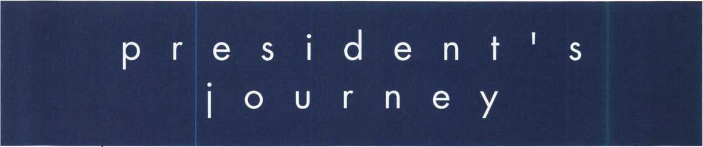

Every issue, we try to focus on something that is of specific use to locksmiths. This issue is only different in that the topics covered this month might not fall into an average locksmith's bread-and-butter category of business. Specialty locks - or locks that are designed for a spe­cific, and perhaps not very mainstream, purpose - can be an important way for a locksmith to grow the business. It's important to always be asking questions of your customers. If you're changing the locks at a residence, it's not impolite to strike up a conversation and ask why, and maybe even what the customer does for a living. Padlocks might be in order for some­one who is often out of town, as are the mounted, key-storage lock boxes often used in the real estate industry. Bike locks are much more prevalent today, with the fitness boom con­tinuing and young professionals moving back into downtown sectors of major cities so they can avoid traffic and live close to work. At the same time, locksmiths have some great chances at selling new products in commercial markets. Products such as the Videx Cyber- Lock are a great example of how a new product can create a new market out of nowhere. Technology is enabling us to strengthen and expand our customers' feeling of security, which is such an enormous plus in today's world. So soak in these articles with the idea that although they may not form the backbone of your business, they can help you expand in new ways that weren't there before.

See you next month, Randy Simpson, CML

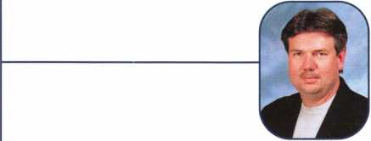

Keynotes • February 2003

**ALOA Scholarship Foundation, Inc.  
Scholarship Application**

3003 Live Oak Street; Dallas TX 75204  
(214) 827-1701, (800) 532-2562

Please print or type **Name**

**Home Address . Home Phone**

**Present Employer .**

**Work Address**

**Work Phone**

**Position**

PRP/STPRP **Level . City**

ALOA/SAVTA#.

**State Zip**

**Dob**

**Educational Level**

(years) **Degree, If Any_**

**Supervisor’s Full Name . City**

**State**

**Zip .**

**Fax**

**Full Time**

**Part Time**

**Take Home Pay**

**Length Of Time In Locksmithing**

**Marital Status Number Of Dependents Classes Desired**

**Membership In Trade Associations (List By Name) .**

**Household Annual Gross Income**

**Date Of Classes**

**Organization Sponsoring Classes:** ALOA.

SAVTA

**Other .**

**Location**

Applications will be reviewed by the ASF Selection Committee on an objective and nondiscriminatory basis. All materials and information pertaining to the applicant’s financial status and background shall be held in strict confidence by the Selection Committee.

ALOA Scholarships are granted to selected individuals desirous of entering the locksmithing field or to selected individuals already in the locksmithing field who wish to improve their professional skills through education.

Applications for classes must be received 60 days prior to the date of the class, and will be reviewed as they are submitted. Scholarships for classes at the ALOA or SAVTA convention will be awarded each year at the ALOA Scholarship Foundation meeting preceding the convention and must be received by March 1 each year.

Please attach to this form a letter stating your reason for applying for a scholarship, what you plan to do with the knowledge you obtain and any other information you feel may be helpful to the scholarship board in making its decision. In addition, attach three letters of reference from individuals who have personal knowledge of your background and character. The letters should contain their names, addresses and phone numbers. It would be helpful if at least one of these references is an ALOA or SAVTA member. All scholarship recipients will be required to provide a 3” x 5” photograph of themselves.

**Application Checklist**

Only complete applications will be considered for scholarships. An application is considered incomplete unless ALL of the above requested information is received before the deadline: 60 days prior to the classes desired, March 1 for ALOA/SAVTA convention classes. Please send this application after checking off each of the below.

* I have filled in each blank on this form.
* I have written and enclosed a letter explaining my reason for applying.
* I have enclosed three letters of reference.
* I am submitting this in time to be received 60 days prior to the date of a class or by February 1 for ALOA/SAVTA convention classes.
* I have enclosed a 3” x 5” photograph.

**Certification Of Applicant**

I certify that the information contained herein, and all supplemental forms are complete and correct to the best of my knowledge. I further certify that if I am selected as a scholarship recipient I will use the knowledge gained for the improvement, development and advancement of the lock­smithing profession. Also, if asked by an authorized ASF official, I agree to give proof of the information that I have given on this application. I also understand that this proof my include copies of my previous year’s Federal Tax Return. I also understand that if no proof is given when request­ed, I may not receive consideration for an ALOA Scholarship Award. I understand that this application is valid only for the event/class specified.

SignatureDate

Please send all completed applications to:

ALOA Scholarship Foundation, Inc. • 3003 Live Oak Street • Dallas, TX 75204

Revised 12/01

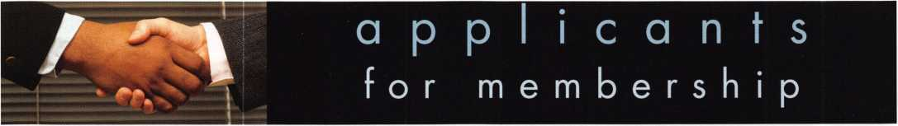

AZ

GA

Ml

PA

VA

Mesa

Jesse B. Martin

Sponsor: William Lee CRL

Tempe

M Laine Key Paul J. Niemi

CA

Fremont

Hashmatullah Nawabi

San Francisco

Mi Ying Lin

Sponsor: Michael F. Owens

CO

Colorado Springs

Thad N. Hoff

Sponsor: Michael P. Habinck RL

Monte Vista Mark D. Renshaw

*FL*

Lakeland

Michael F. Connelly Tampa Tim Otero

Macon

Grant Edwards

Sponsor: Clifford D. Lipscomb CMC CPS

IL

Orland Park

Pavel Balaz

Sponsor: John J. Greenan CML, CPS

MA

Salem

Robert Auch

MD

Gaithersburg

David L Tracey CRL

Sponsor: Gregory A. Jacobson CRL

Landover Hills

Stanley B. Johnson

Sponsor: William J. Carter

Dearborn Hamburg

Christopher A. Bak CRL Chris Unger

Sponsor: Michael R. Schleyer CPL phi|ade|phia

Stephen Weiss

NC

Wilson

Steven C. Hooker

ND

TN

Memphis

Glen Peifer

Bismarck

TX

Mark Knudson

Sponsor: William K. Ortmann CRL

NE

Kearney

Paul A. Zapata

Sponsor: Kelly D. Hardin CRL

Aledo

Gerald Plumlee

Sponsor: Jack E. Street CRL

Ingleside

Steven E. Morehead

Sponsor: Bill F. Roth

Itasca

NY

Brooklyn

Paul Giacalone

Lynn L. Seward CRL

Sponsor: Joseph H. East Jr

Longview

Buck Coulter

Lubbock

OK

Stillwater

Roger M. Cude

Sponsor: Larry K. Viaille CML

Richard H. Hall

Arlington David Braden

Sponsor: Michael B. Groves

Andy Schultz

Sponsor: Michael B. Groves

VT

Burlington

Eric L Dion

Wilmington

Larry M. Nutting

Sponsor: Harold I. Rice

WA

Kent

Randy G. Zabel

Medical Lake

Michael J. Bogulaski

Ireland

Raheny

Barry Lynch

Taiwan

Taipei

Anne L. F. Lin

Sponsor: Dong-Hoon Song

These applicants are scheduled for clearance as members of ALOA. The names are published for member review and comment within  
30 days of this Keynotes issue date, respectively, to ensure applicants meet standards of ALOA's Code of Ethics. Protests, if any, should  
be addressed to the Membership Department and must be signed. Active Membership applicants (a) have worked in the industry two or  
more years. Allied Membership (AL) applicants are not locksmiths, but work in a security-related field. Apprentice Membership (AP)

applicants have worked in the industry less than two years.

Keynotes • February 2003



Kaba Mas manufactures and markets locking solutions for all levels of container security.

Our self-powered and battery powered locks were developed specifically for today’s business environment, addressing the requirements of retail, commercial, government and industrial markets.

For more information on our products, visit us on the web at: [www.kaba-mas.com](http://www.kaba-mas.com)

|  |  |  |
| --- | --- | --- |
| 1 | | |
| KABA  MAS | The Brand for Safe Locks  [www.kaba-mas.com](http://www.kaba-mas.com) | A Member of  the Kaba Group lAoN  KARA |

**upcoming**

10 Greater Dallas Locksmith Assoc. Membership Meeting • 7:30 pm Han Johnsen Company Landy Dyess (972) 682-0505

11

Greater Houston Locksmith Assoc. Membership Meeting 7:30pm Judy Clifford (979) 297-2413 <http://ghla>. lcis.com/index.html

13 The Locksmith Security Associa­tion of Michigan offers classes Detroit, Ml William M. Lynk [icores@earthlink.net](mailto:icores@earthlink.net)

19 Central Florida Locksmith Assoc. Membership Meeting 7:30pm Orlando, FL

Jim Riley (863) 294-8679



10 Greater Dallas Locksmith Assoc. Membership Meeting 7:30pm Han Johnsen Company Landy Dyess (972) 682-0505

11 Greater Houston Locksmith Assoc Membership Meeting 7:30pm Judy Clifford (979) 297-2413 <http://ghla>. 1 cis.com/index.html

15 Japan Chapter of ALOA Annual Conference Seoul, Korea Hidetomo Kimura 81-45-983-6643

16 Japan-Korea Chapters Joint Conference Seoul, Korea Hidetomo Kimura 81-45-983-6643



8 Greater Houston Locksmith /

Membership Meeting 7:30pm  
Judy Clifford (979) 297-2413

http:/ / ghla. 1 cis.com/index.html

Greater Dallas Locksmith Assoc. 16 Membership Meeting 7:30pm Han Johnsen Company Landy Dyess (972) 682-0505

Central Florida Locksmith Assoc. Membership Meeting 7:30pm Orlando, FL • Jim Riley (863) 294-8679

24-26 Colorado Security Profes­sionals Education Conference Denver, CO • Gordon Racine, CML 719-384-4707 [racine@rural-com.com](mailto:racine@rural-com.com)

**UPCOMING PRP SITTINGS**

2/14/2003

2/23/2003

3/2/2003

3/14/2003

3/15/2003

3/16/2003

4/5/2003

4/6/2003

4/11/2003

4/26/2003

5/9/2003

8AM • Dallas, TX • ALOA

Janelle Ramirez 800/532-2562 x30

10AM • San Antonio, TX

TLA • Judy Clifford 979/297-2413

8AM • Maplewood, MN

MN Chapter of ALOA

Dana Lee, CML 612/968-4500

8AM • Dallas, TX • ALOA

Janelle Ramirez 800/532-2562 x30

10AM • Chamblee, GA

GA Chapter of ALOA

John C. Elliott, Jr., CML, CPS

770/314-7859

8AM • Troy, Ml

IDN Hardware Sales, Inc.

Bonnie Weston 734/591-4821

9AM • Somerset, NJ

MLANJ • Dan McGlynn, CML

732/932-9857

8AM • Chicago, IL

Clark Security Products

Joan Emrick 619/718-7308

8AM • Dallas, TX • ALOA

Janelle Ramirez 800/532-2562 x30

6PM • Denver, CO

CO Front Range Chapter

Gordon Racine, CML 719/384-4707

8AM • Dallas, TX • ALOA

Janelle Ramirez 800/532-2562 x30

|  |  |
| --- | --- |
| 5/16/2003 | 6PM • St. Charles, MO  Bi-State Chapter  Kenneth Kim, CPL 314/351-7252 |
| 5/17/2003 | 5PM • Seattle, WA  KDL Hardware Supply, Inc.  Julie Pilgrim 206/682-738. |
| 6/13/2003 | 8AM • Dallas, TX • ALOA  Janelle Ramirez 800/532-2562 x30 |
| 6/22/2003 | 8AM • Reno, NV  Clark Security Products  Joan Emrick 619/718-7308 |
| 7/11/2003 | 8AM • Dallas, TX • ALOA  Janelle Ramirez 800/532-2562 x30 |
| 8/8/2003 | 8AM • Dallas, TX • ALOA  Janelle Ramirez 800/532-2562 x30 |
| 9/12/2003 | 8AM • Dallas, TX • ALOA  Janelle Ramirez 800/532-2562 x30 |
| 9/21/2003 | 8AM • Anaheim, CA  Clark Security Products  Joan Emrick 619/718-7308 |
| 10/10/2003 | 8AM* Dallas, TX • ALOA  Janelle Ramirez 800/532-2562 x30 |
| 10/18/2003 | 10AM • Chamblee, GA  GA Chapter of ALOA  John C. Elliott, Jr., CML, CPS 770/314-7859 |
| 11/14/2003 | 8AM • Dallas, TX • ALOA  Janelle Ramirez 800/532-2562 x30 |
| 12/12/2003 | 8AM • Dallas, TX • ALOA  Janelle Ramirez 800/532-2562 x30 |

|  |  |
| --- | --- |
| UPCOMING ACE CLASSES | |
| Feb. 22-23 | Montgomery, AL  Alabama Locksmith Assoc. |
|  | Amanda Floyd 334/793-5060 |
| Feb. 28-  Mar. 1 | Maplewood, MN  Minnesota Chapter of ALOA  Dana Lee, CML* 612/722-9181 |
| Mar. 1-2 | Marion, IN  Northern Indiana Chapter  John F. Curtis 765/662-11 85 |
| Mar. 24-28 | San Diego, CA • SAVTA  David Lowell, CML, CMST 800/532-2562 XI8 |
| April 3-6 | Somerset, NJ • MLANJ  Dan Mcglynn, CML  732/932-9857 |
| April 24-26 | Denver, Colorado • Colorado Front Range Gordon Racine, CML 719/384-4707 |
| May 16-1 8 | St. Charles, MO • Bi-State Chapter Kenneth Kim, CRL, CPS 314/351-7252 |
| July 14-18 | Las Vegas, NV • ALOA  David Lowell, CML, CMST 800/532-2562 x!8 |

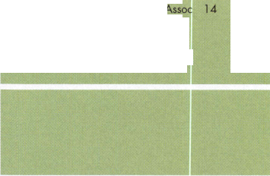

**events**

19-22 Texas Locksmith Association 40th 21 Central and Southern Colorado Annual Convention and Tradeshow Locksmith Assn. Regular Meeting

San Antonio, TX Colorado Springs, CO

Butch Titus 210-649-2166 Mike Middick 719-275-7787

[captkeyman@juno.com](mailto:captkeyman@juno.com)

|  |  |
| --- | --- |
| 19 Central Florida Locksmith Assoc. 21 | Central and Southern Colorado |
| Membership Meeting 7:30pm | Locksmith Assn. Regular Meeting |
| Orlando, FL | Colorado Springs, CO |
| Jim Riley (863) 294-8679 | Mike Middick 719-275-7787 |
|  | [captkeyman@juno.com](mailto:captkeyman@juno.com) |

|  |  |
| --- | --- |
| 26 Nebraska Locksmith Association | 29-3 Security Hardware Distributors |
| Educational Classes 9am - 5pm | Assoc. Annual Membership Conf. |
| Omaha, NE • Bernard Dobesh | Ponte Verde Beach, FL |
| (308) 381-4440 | Talbot Gee 215-564-3484 |
| Key ma n 3 @cha rter. net | [www.shda.org](http://www.shda.org) |

Locksmith Training

Sponsored by Fox Valley Technical College • 1825 N. Bluemound Dr. • Appleton, Wl 54912-2277

6-Day Program • Career Change in One Week • March 3-7, 2003

This is a basic locksmithing training course sponsored by FVTC’s Security and Crime Prevention  
Department and conducted by ALOA ACE instructors. Designed for the locksmith shop owner  
who would like to provide entry-level training for new apprentice locksmiths as well as those who

would like to receive professional training that will enable employment with a professional locksmith. The course will allow the student  
to gain enough knowledge to make them a starting apprentice in an existing shop. Job placement locations will be made available at the  
time of the class.

To maintain quality the course enrollment will be capped at 12 students. Enroll early!

Curriculum includes:

Key Blank Identification and Duplication Lockset Servicing, Functions, Finishes Pin and Disc Cylinder Servicing Door Closers

Key Codes and Code Equipment Life Safety Codes ^eY Impassioning Lockset Installation

Basic Master Keying Lock Pick Opening Techniques *"°ck ^Y'^ass Techniques Cabinet, Furniture, Mailbox Locks

Exit Flardware

All tools and equipment will be made available for use during training.

Class Hours: 8:30 am to 5:00 pm every day  
Class Attire: Shop clothes  
Course Tuition: $995.00



Course Enrollment: See Susan Egnoski in the Criminal Justice Center

or call 920-831-4393

Note: Enrollment deadline is Friday, September 20, 2002

Part 2

By Sal Dulcamaro, CML

In part i (December 2002), I described the basic con cept of the Videx CyberLock system of electronic access control. Here in part 2, we will expand our examination and go deeper inside the CyberLock to see what makes it tick. First look at the illustra­tion in figure 1 to observe a cutaway see-through view of a CyberLock cylinder and CyberKey. Both the mechanical and electronic parts are extremely tiny and designed to operate in fairly extreme and harsh conditions.

Since the heart of the system is centered around an electronically enhanced mechanical lock cylinder, it can be installed just about anywhere, and it goes into virtually anything that uses an ordinary mechanical lock cylinder; a place where few other brands or sys­tems can follow.

Keynotes • February 2003

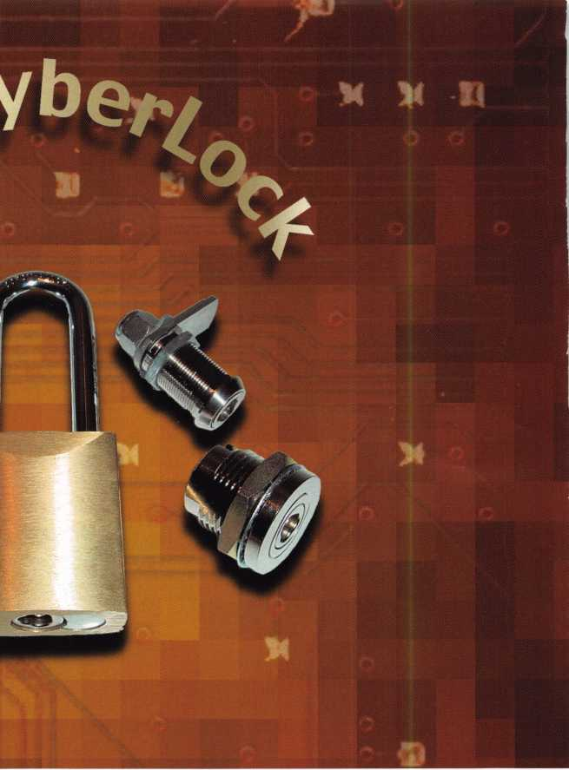

Inside the CyberLock Cylinder

Photograph 1 shows a back view of the “6-pin Schlage Format” Videx CyberLock cylinder. It bears a very close resemblance to a normal Schlage 6-pin mechani­cal lock cylinder. At this point, the CyberLock cylin­der only lacks a tailpiece that would adapt it to a spe­cific lockset. Along with both “six and seven-pin Yale Format” cylinders, this format lock cylinder would be how the Videx product would bring electronic access control into a large variety of (otherwise strictly mechanical) cylindrical locksets and auxiliary/specialty locks that accept knob type cylinders. Availability of tailpieces or adapters would be your greatest limiting factor.

Along with the CyberLock cylinders for cylindrical locksets, there are mortise and rim type cylinders that are designed to upgrade mechanical door hard­ware to the potential for electronic access control. Externally the Videx cylinders are basically the same size and shape as conventional mechanical lock cylin­ders. That characteristic is what allows a near seam­less integration of sophisticated electronic security into what was formerly just mechanical security.

The action of engaging a key to a lock and a mechani­cal actuation of the lockset is very similar in the Videx product compared to strictly mechanical locks. The insides of the CyberLock cylinders and their capabilities have no comparison.

Inside, there are no mechanical tumblers like a real 6- pin Schlage lock cylinder, and there is no need for dis­assembly of the CyberLock cylinder to “rekey” it. If you look back to photograph i, the threaded cap at the back of the lock cylinder does not use a spring- loaded retainer pin to keep the cap from unscrewing. It uses a small internal hex head screw and requires an Allen wrench, as in photograph 2, to remove it. There is a matching threaded hole on the right side at top (viewed from the back) to place the screw, in order to change the tailpiece orientation.

Once the screw is removed, the threaded cap can be unscrewed as in photograph 3. When the cap is com­pletely off, the plug will not just fall out. Somewhat like a pin tumbler lock cylinder, you must have a working key to allow the locking pin to retract in order to release the plug from the shell. Touch the key to the contacts on the face of the plug. Then push the key inward until you are able to make the plug

rotate. While  
the plug is rotat-  
ed, the inside  
wall of the shell  
will keep the  
locking pin  
compressed.

Then the plug  
can be pulled  
out of the shell.

The plug has  
been removed  
from the shell in  
photo 4. The  
locking pin is  
toward the tail  
end of the plug  
and extends  
upward from  
the top surface  
of the plug. This  
pin is spring

loaded, so if you remove the plug from the shell (as I did), be careful that the pin does not shoot out, as the plug is withdrawn from the shell. The shell is to the left of the plug, and the front surface of the shell is facing forward. The slight recess at top, on the inside surface of the shell, is there for a small ball bearing that retains the key during lock operation.

The shell and plug have been turned around in photo 5, to reveal the back sides of both. A much larger recess inside the shell can be seen on this side. This one is for the locking pin, which can also be seen in

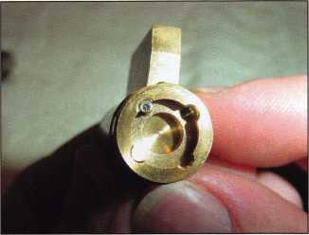

Photo 1

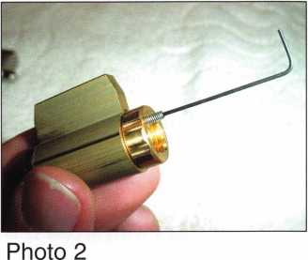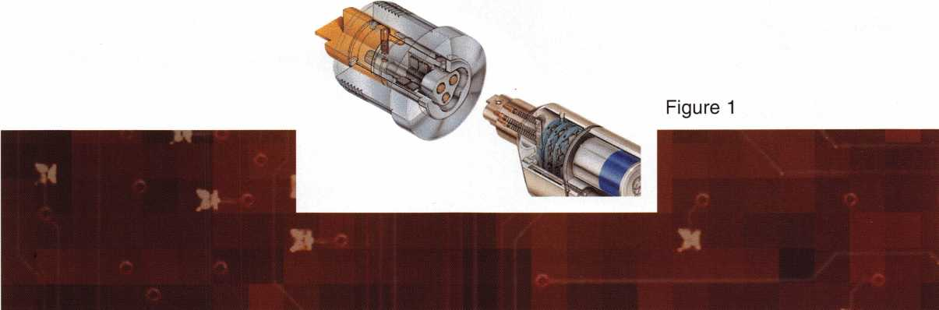

Keynotes • February 2003

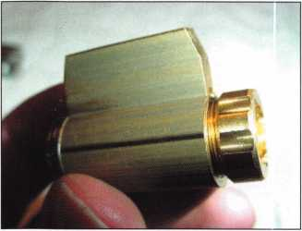

the plug from  
this view. A top  
view of the  
plug, in photo  
6, reveals a few  
of its features.  
There is the  
locking pin,  
a two piece  
separable plug  
and a key  
retaining ball.

The locking pin has been removed in photo 7, the spring in photo 8. Looking down into the hole, it is very difficult to see the blocking pin that prevents the locking pin from completely compressing within the top surface of the plug. The electronics and circuitry are contained within the body of the plug. Also with­in the plug is a solenoid that is actuated when a prop­er electronic key with access is engaged to the CyberLock. When actuated, the blocking pin is pulled back (toward the direction of the face of the plug) and the space below the locking pin is opened. Because the locking pin is spring loaded, it won’t compress until rotational force pushes the pin down­ward into its hole. With the blocking pin out of the way, the locking pin can fully compress as the plug is turned to open the lock.

If you look back at photo 8, you may notice that the  
front and back parts of the plug appear to be made up  
of different colored metal sections that are held  
together by a metal retainer ring. If rotational force is  
applied to the front end of the plug (and a proper key  
is not engaged), the locking pin in the back section of  
the plug will engage the slot within the shell and  
resist. Since a key has not caused the blocking pin to  
draw back, the locking pin cannot compress within  
the body of the plug. When sufficient torque is  
applied, the front end of the plug will begin to turn  
and the two parts will separate. The back portion will  
expand as the front and back separate, and the lock  
will remain wedged shut.

Now let’s get back to the key retaining ball. Photo 9  
shows a front view of a CyberLock cylinder plug and a  
tip side view of a CyberKey. You can see the electrical  
contacts of both where data and power are  
exchanged. If you look carefully into the plug face,  
you can see the key-retaining ball at the top within  
the keyway opening of the plug. A top view of the  
plug and key is shown in photo 10. The key-retaining  
ball is just below the surface of the plug (near the face  
end), before the key might be inserted into the key-  
way. A hole in the top of the key’s front surface is  
designed to accept the metal ball and lock the key  
into the face of the plug during rotation. When the  
key is inserted, the initial thickness of the key pushes

the ball upward into the recess of the  
shell (when assembled inside the  
shell). The ball then prevents rotation  
until the key is fully inserted. That is  
true even if the solenoid draws back  
the blocking pin. When the key is  
inserted far enough inward, the  
ball will engage the key and the plug

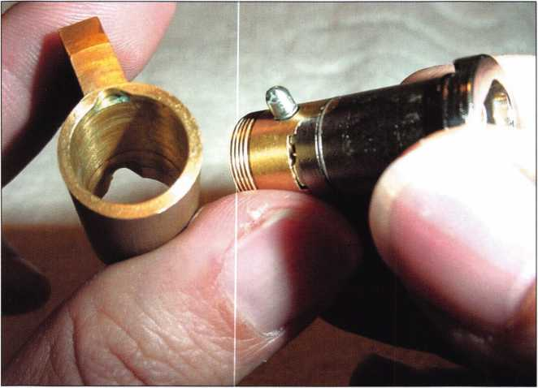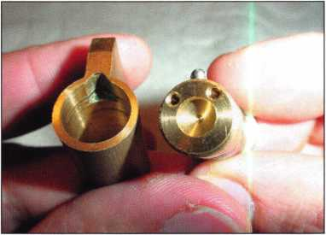

Photo 4

Photo 5

**2**

Keynotes • February 2003

can rotate. That ball will prevent key removal until the key is returned to its proper removal position.

CyberLock Cylinder Security

Some of the features that I have just described would be related to the cylinder’s security. The way that the front and back halves of the plug separate is called a “torque brake.” The unique physical design of the lock cylinder makes it pick proof from more conven­tional picking tools. Since the cylinder will often be installed within other lock hardware, it will not be able to prevent bypass methods to which any particu­lar lockset (in which it is contained) might other oth­erwise be vulnerable. A CyberLock cylinder also con­tains a tamper pin. If the front of the cylinder is struck with blunt force, a tamper pin will drop into a position to prevent the lock from opening. The tamp­er pin can be repositioned back to its original (pre­impact) condition by touching the lock face several times with an authorized user key.

Since the CyberLock is also electronic, it might deal with other threats to its physical integrity. The heart of the CyberLock cylinder is an extremely compact circuit board with microprocessor and memory stor­age. The circuit board within the CyberLock cylinder is potted to resist salt air, weather or other environ­mental conditions that might challenge it. It has faced a stun gun at 300,000 volts and remained locked and similarly resisted rare earth magnets up to 18,000 gauss.

Unconventional Electronic Access Control

Most brands of electronic access control lock prod­ucts are somewhat large in size and bulky. That is not generally a disadvantage in the more conventional

application of electronic access control-the standard entry door. Where it becomes a problem is in the otherwise unconventional application of electronic access control. Virtually any locking situation involv­ing money, valuables, safety, or controlled substances/items is a candidate.

The problem in many cases is the physical retrofitting in some rather awkward places. Most of these situa­tions find a functioning mechanical lock cylinder in place, but a conventional mechanical cylinder cannot limit access by day or time and it certainly can’t keep track of when it was opened or by whom. This is where the Videx product stands out with few peers. Using just a little imagination, it shouldn’t be too hard to think of many applications outside of entry doors where access control and audit are a virtual necessity.

Photo 11 shows one of three vending machine type CyberLock cylinders. There is a spring latch standard length, spring latch short and a dual action cylinder. The dual action cylinder can act as a deadbolt and

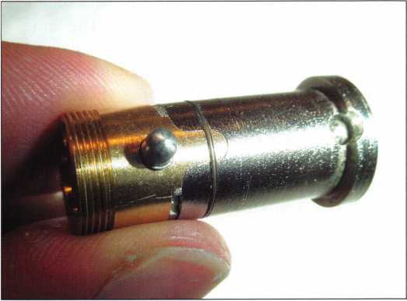

Photo 6

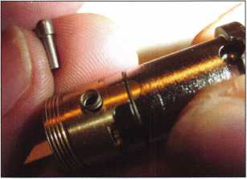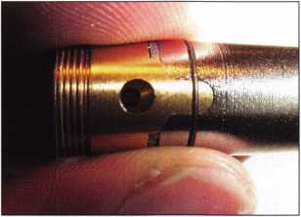

Photo 7

Photo 8

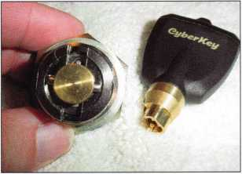

Photo 10

Keynotes • February 2003

Photo 11

Photo 12

Photo 13

can be relocked without using a key. Like a conven­tional vending machine lock, in photograph 12, the CyberKey is used to retract the latch to ultimately unlock the vending machine. The big difference is that most vending machine locks won’t remember whose key opened them and at what time. Vending machines are an ideal target market for CyberLock. They are usually securing money, merchandise or both.

Photo 13 shows a CyberLock cam lock with some accessory parts for specific applications. The cam lock has a lot of potential because it ends up on a wide variety of drawers, cabinets, containers and enclosures. With different accessories, it can be restricted as key retaining or the same cam lock can be set to allow key removal when locked or unlocked. In the key retaining mode, a cam stop can limit the rotation to 90 degrees. In that mode, since the key has only one removal position, the cam must be relocked in order to remove the key. A slightly more complex mechanism allows for 90-degree rotation and key removal in locked or unlocked condition (photos 14, 15 and 16).

Vending machines that are used for bill changing or ticket/token dispensing will sometimes use a remov­able plug lock cylinder. Videx makes a variety of spe­cialty lock cylinders including a CyberLock version of that lock type, shown in photo 18. It is usually mount­ed in front of a bolt that secures the door of the device. Photo 20 shows the CyberKey rotating the plug 90 degrees, which allows it to be removed (photo 21). Once the plug is removed, a previously concealed Allen head bolt will typically secure the door. The open space revealed in photo 22 is where that bolt head would usually be. Once the bolt was loosened with an Allen wrench, the door could be opened.

Videx makes switch locks and other specialty or auxil­iary locking cylinders for many other special applica­tions. If they don’t make them yet, they probably can. There will probably be certain electronic access control applications that are not best suited to CyberLock, but for others there is almost no other way to go. I will try to finish up things in part 3 by covering CyberLock interchangeable cores, CyberKeys, some other special applications, program­ming and auditing. D



C am lau_Y,

Latch pin

Drive cam

NylocV. nut

**CyberLock** Can*

Horizon**1

e

Locking boss

Cylinder tendon

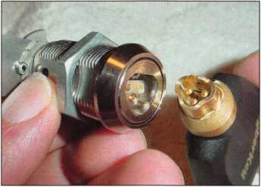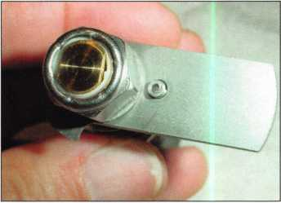

Photo 14

Photo 15

Photo 16

Keynotes • February 2003

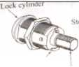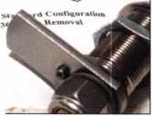

Photo 18

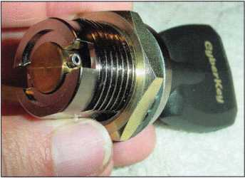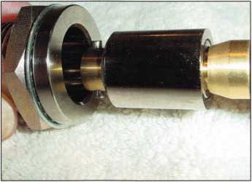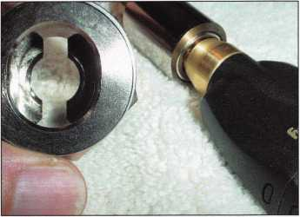

Photo 20

Photo 21

Photo 22



Colorado Security Professionals Education Conference

April 24, 25, 26, 2003

Brought to you by the following:

* Central & Southern Colorado Locksmith Association • Rocky Mountain Locksmith Association
* Colorado Burglar & Fire Alarm Association • ALOA Front Range Chapter

Thursday, April 24, 2003

4 Basic Locksmithing (Day 1 of 2) 4 Masterkeying 4 Jail and Prison Locks • Access Control (Day 1 of 2)

Evening:

Free Dinner Buffet  
and Trade Show

Drawing for a  
Free Convention Package  
at ALOA Las Vegas

and Prizes 6pm to 10pm!

Friday, April 25, 2003

4 Basic Locksmithing (Day 2 of 2) 4 Small Format IC core (PRP)

4 Safe Lock Service & Troubleshooting (PRP)

• Access Control (Day 2 of 2)

Evening:

Fun Night Out!

Bus trip to

Colorado Central Station  
Casino Blackhawk  
One of Colorado's  
Oldest Mining Towns

Only $10.00!

Saturday, April 26, 2003

4 Large Format IC Core (PRP)

4 Servicing Aluminum Storefront Doors 4 Electronic Safe Lock Service • Life Safety Codes

Evening:

Free Labor Saver Class  
ALOA PRP Testing

Gordon Racine, CML 719-384-4707  
Barry Meyer, CRL 303-688-4104

Please thank and support these generous show sponsors: IR Security & Safety, Intermountain Lock and Supply Co., Clark Security Products,

International Distribution Network, Access Hardware Supply, ASSA

4 = ALOA ACE Education • = NBFAA Education

**For more show information go to:** [**www.Radisson.com/SecurityEducationWeekend**](http://www.Radisson.com/SecurityEducationWeekend) **or email** [**racine@rural-com.com**](mailto:racine@rural-com.com) **or** [**Acomal@Qwest.net**](mailto:Acomal@Qwest.net)



Keynotes • February 2003

2000 Ford F-150 Harley Davidson

By Jeff Trepanier, RL

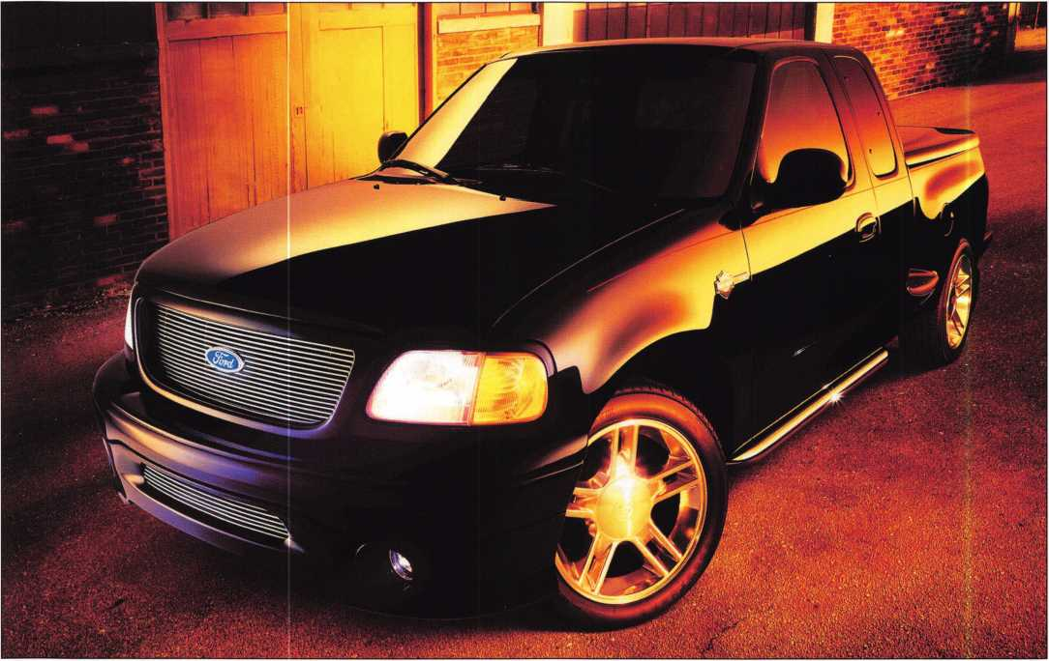

2000, black Ford F-150 Harley Davidson, 4x2 pickup. This key has 8 cuts and is equipped with a transponder key system. There’s no locking glove box lock and the console between the seats does not lock.

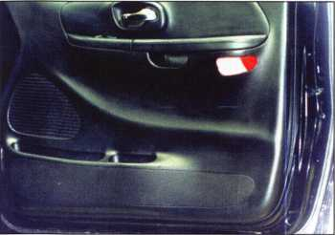

5. To remove the door panel, first remove the trim by hand, starting at the top and working downward. A panel tool can be used as well. If you choose to use a panel tool, use care to avoid damage and paint scratches.

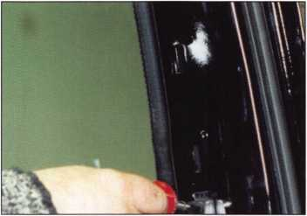

6. Use a phillips-head screwdriver to remove the door panel.

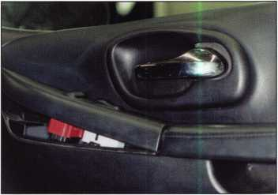

7. Remove the armrest control panel by gen­tly prying the front, which is hooked at the rear with a clip. Next, unplug the wires and gently pry at the front of the door handle trim to remove completely.

**6**

Keynotes • February 2003

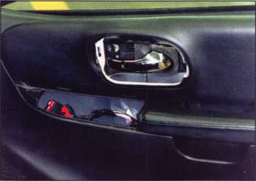

8. Armrest Control Panel and door handle.

**AUTHOR DOES NOT RECOMMEND REMOVING THE DOOR LOCKS COMPLETELY.**

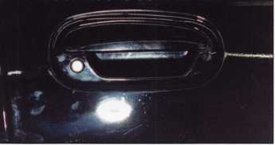

1. The door handle assembly is somewhat difficult to remove. An alternative is to remove only the lock cylinder. However, the cylinder is concealed and must be removed by hand without tools. Because there is no visibility, removal must be done by feel alone. Locate the bottom of the clip and lift down and toward the edge of the door. The clip should stay in place. Next, slide the lock out of the door handle assembly and unhook from lock rod link­age. If there is existing damage, the lock will have to be replaced and rekeyed.

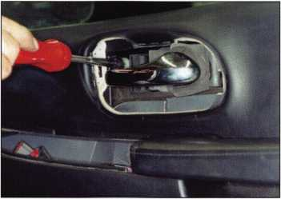

9. Continue the door panel—remove by gen­tly lifting up and away. DO NOT remove the door panel completely until you have unplugged the door panel light. There are 11 hooks inside the door panel.

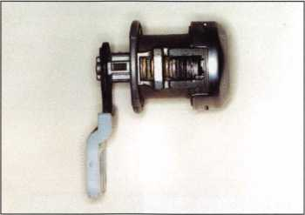

1. Bottom view of the door lock cylinder. Through the drain hole, you can see wafers 1-6. This lock can be disassem­bled for further service by gently removing the face cap. Next, remove the clip from the back and remove the tail.

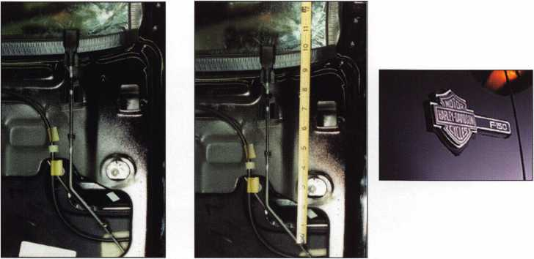

1. Door opening tool on lockrod. The window on this vehicle is hard to wedge open and extreme care should be used to pre­vent glass breakage. The window should be wedged open in the center. The Author used a hook-ended tool. A Slim Jim with an inward bend is another option. Locate the lock rod and lift up. There is a large contact area so depth will vary depend­ing on the type of tool and procedure used.
2. Photo shows a depth of about 10” to the center of the contact area of the lock rod.

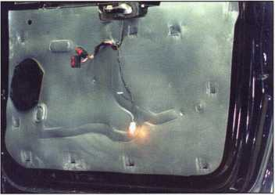

10. Door panel removal is complete.

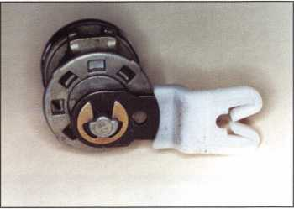

1. Rear view of door lock.

Note: this door lock and it’s retaining wire appear to be the same as the tailgate lock and retainer.

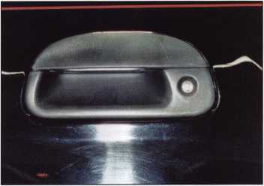

16 .A close-up view of the rear tailgate lock in the handle.

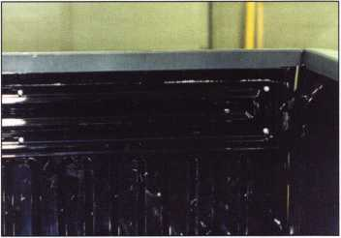

17. View of inside bed with the tailgate up. Notice 4 of 6 #30 screws that need to be removed when the tailgate is opened and remove the panel.

Keynotes • February 2003

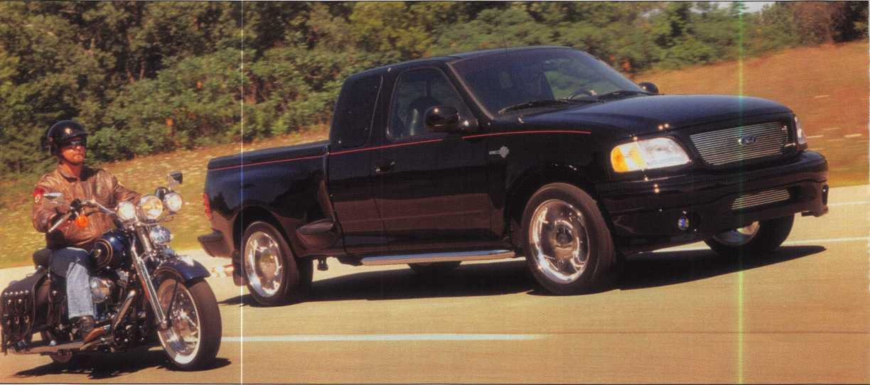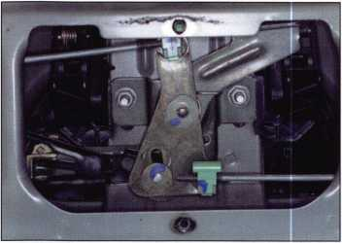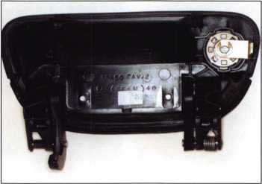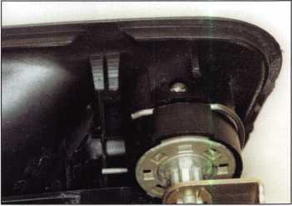

20. Inside view of tailgate lock and handle 21. Tailgate handle with lock and

assembly. To remove handle assembly, retaining wire.

simply remove two 10mm nuts.

22. Closeup of the retaining wire for the lock cylinder. Remove the wire and pull out the lock.

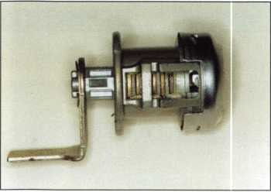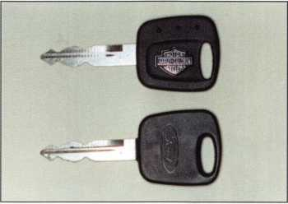

23. Bottom view of the tailgate lock. Wafers 1-6 are visible through the drain hole. Using specialty tools, fit a key to the tail­gate lock and find the last two cuts for the ignition cylinder by process of elimination. Note: This lock cylinder with a differential and retaining wire appear to be the same as the door lock.

24. Harley Davidson key appears at top of photo.

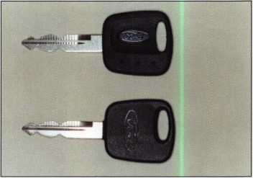

25. 2 Ford keys with transponders. Harley Davidson Keys cannot be purchased from any distributor. Contact the dealership for part number 164-R0461, Rotunda Pats Key with Jewel. Equivalent keys can be purchased from STRATTEC (#59833), llco (#H72-PT), Lockmasters (#LKMH72PT). The keys pictured in this photo were pur­chased from STRATTEC (Note “S” stamped on each key).

**8**

Keynotes • February 2003

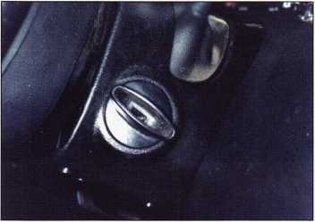

26. Ignition cylinder on right side of steer­ing column. To remove the ignition cylin­der, turn the ignition to the “on” position with a key or by picking it with an A-1 Pick Kit. Push in on the retainer through the hole provided in the lower column shroud. Next, pull out the ignition cylinder.

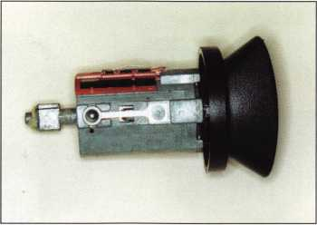

27. The ignition cylinder and active retainer.

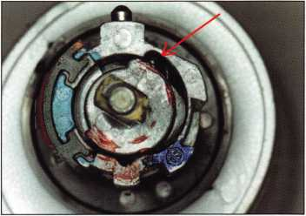

28. End view of the cylinder turned as far as it will go. To disassemble, push down on the ball bearing (located in the 1 o’clock posi­tion). Continue to rotate the ignition plug so the ball bearing is below the retainer. Carefully remove the retainer, ball bearing and spring. Finally, remove the plug from the housing, being careful not to damage the buzzer tab.

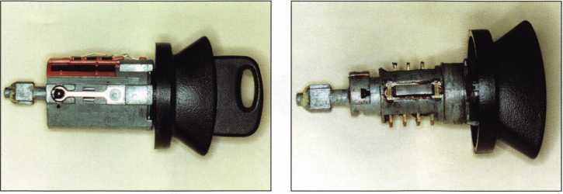

Coming Soon!

Part 2: Programming the  
Ford transponder keys  
with the NGS.

29. Ignition cylinder plug rotated for disas sembly. Note: The key buzzer tab is located at the top center of photo.

The ball bearing is visible, now that the retainer has been removed.

30. The ignition cylinder plug with opposing wafers and a side bar.



New Product

SAFE CORPORATION

Viking Stainless

Fire & Burglary Protection  
State of the Art Composite Fill

Strong • Functional • Attractive

Available in 10 sizes  
to Fit Every Need

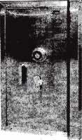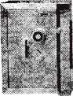

See us at [www.a-bsafecorp.com](http://www.a-bsafecorp.com)

1*-*800*-*253-1267

Fax 856-863-1208

CALL FOR YOUR CATALOG TODAY

Keynotes • February 2003

New for the Street

By Billy B. Edwards Jr., CML

Street Cuff is a new high security bicycle and motor­cycle lock from Master Lock Co. Available in two dif­ferent versions, this lock series has the potential to pose some real problems for the locksmith who needs to gain access or remove them.

The laminated version, (8290DPS), is more light­weight weighing in at 31/2 pounds, and is aimed at the bicycle enthusiast. The cast version, (8299DPS) was designed with the motorcycle rider in mind and weighs 7 pounds.

Each version has nine links between the locking cuffs to offer some flexibility of use. The material used for the laminated cuffs is 1050 steel, nickel-chrome plated

and case hardened to Rockwell 50. The cast version uses 1045 Steel with a nickel-chrome plating and the same hardening process.

They have had some impressive results when submit­ted to testing. Each half of the set has been pull test­ed in two directions, and another pull test performed by trying to pull the two cuffs apart. The laminated cuffs routinely qualify at 6,000 pounds, and the cast cuffs qualify at 15,000 pounds.

The cutting tests on the laminated versions typically resist up to 18,000 pounds of force. The cast version is a little harder and the actual limit isn’t known, since the cutting blades break at 25,000 pounds.

Keynotes • February 2003

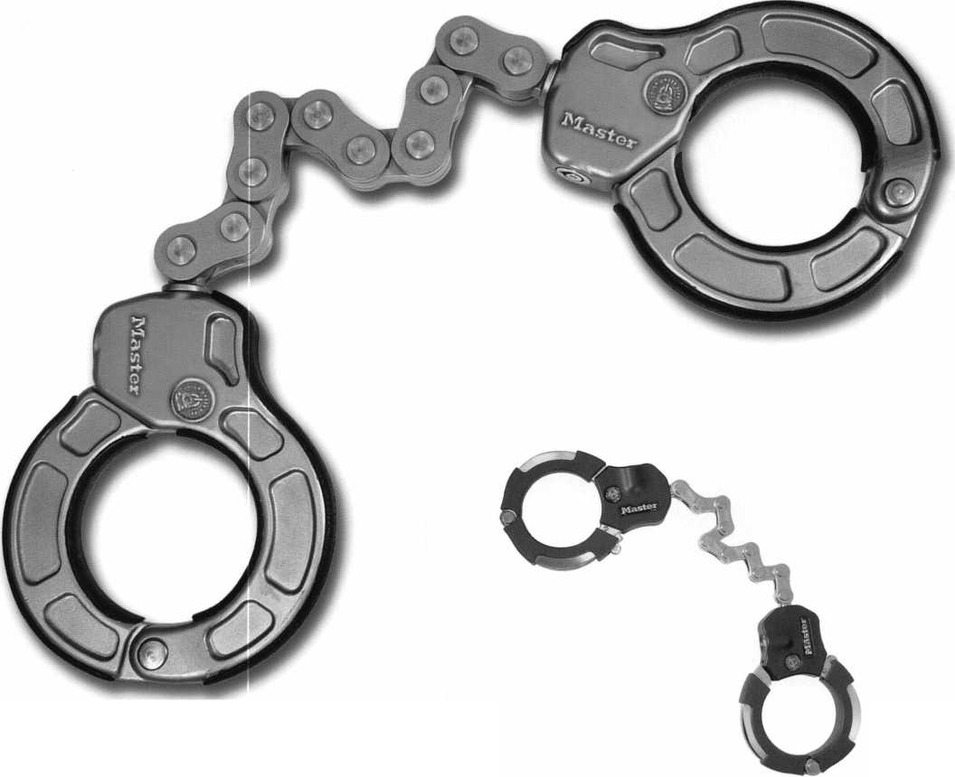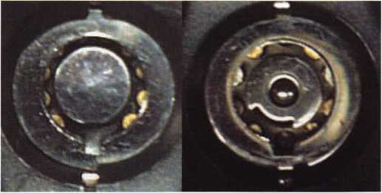

The cylinder used in these locks is tubular, but with some features you may not have seen before.

The most important feature is the push button that locks it. The center post of this cylinder does not turn, ever. It moves in and out. That means that your tubular picks won’t work, since they rely on applying torque via the center post.

The keys are also different from most of the tubular keys you have encountered. They have nine cuts instead of the

For those who want that

‘biker’ look there is also a  
belt holster available.

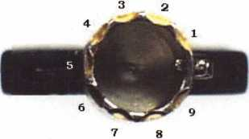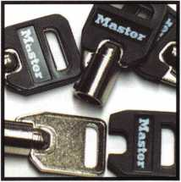

typical seven or eight normal-  
ly encountered. They can be  
duplicated using a 747XU  
tubular key machine. Master

Lock has blanks with a slip-on plastic head available,  
(K8186), or you can use a standard KABA Ilco 1137  
brass or steel blank.

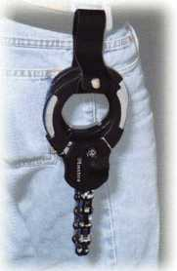

The cylinder also has three hardened dead pins in  
it to resist the hole saw approach of removing the  
pins. It has also been used with two different designs  
(as shown in photo 1). The center post is the major  
design difference. The first version had a fully circular  
post, which meant that the key did not have an inter-  
nal lug in it. That lack of an internal lug posed a prob-  
lem when trying to duplicate a key, since all of the  
duplicators require an internal lug to positively posi-  
tion the pattern key on the machine. The redesigned  
push button cylinder has a cavity in the center post

that allows the key to have an internal lug.

Street Links® is  
another new prod-  
uct now available  
to the locksmith

Street Links"  
is another  
new product  
now available  
to the lock-  
smith. It is a  
5’6” long  
chain with  
hexagonal

shaped links that have

been reinforced with boron and titanium and supplied  
with a nylon cover to keep the chain from scratching  
whatever it helps lock. The part number 8296DPS is  
for the version sold only in bike shops and is supplied  
with a ProSeries® 6321 padlock. Since locksmiths  
already have ProSeries" padlocks, there isn’t a need  
to have the higher price and they can order the chain

only as a part number: 8296D. Q

Keynotes • February 2003

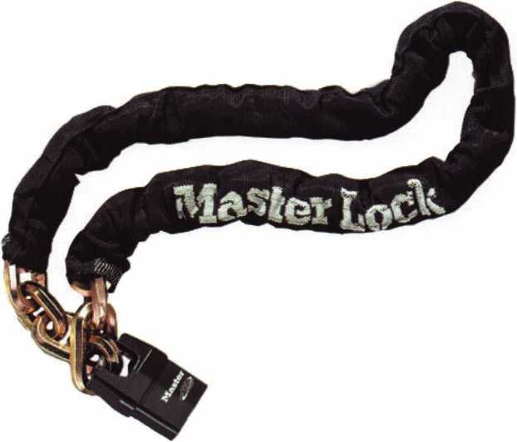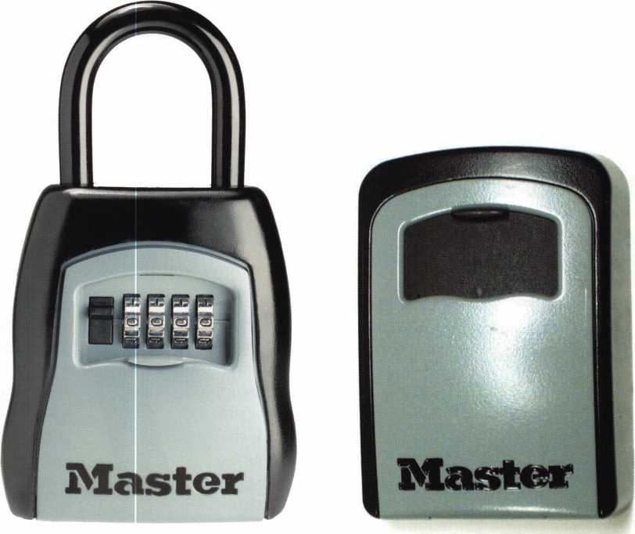

Select Access® from Master Lock Co.

By Billy B. Edwards Jr., CML

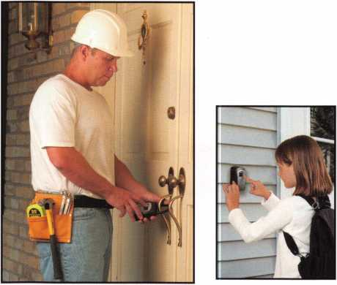

The new key storage units from Master Lock Co. offer a  
new alternative to similar options in the market today  
Two basic types are available through your distributor  
now The 5400D has the appearance of a large padlock,  
and the shackle may be used to lock it onto a doorknob,  
a post, etc. The 5401D wall mountable version is actually  
a little larger (see photo 1). Both storage boxes are hold-  
ing the same keys.

The lock on these key storage boxes behind the black  
weather door is a four-dial combination lock and the  
latch is directly connected to the fence. The combina-  
tions can be reset using a reset lever on the inside of the  
door. In order to reset the combination, it must be set



Keynotes • February 2003

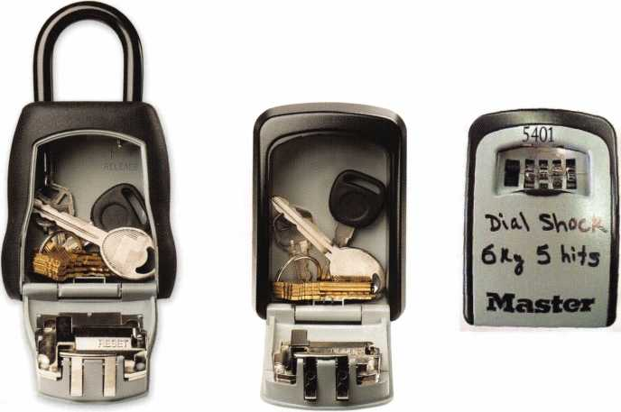

on the opening number, the reset lever moved left and down, the new combination dialed and the reset lever moved back to its normal position.

While both boxes are of metal construction, the 5400D has a soft cover to keep it from denting or scratching a door surface. Installation and removal of the 5400D is an easy process as well. Inside the com­partment, there is a movable projection that unlocks the shackle to allow easy installation or removal.

The 540iD is designed to be mounted via the four mounting holes accessible from inside the compart­ment. The unit is supplied with four 1 1/4-inch screws for this purpose, and should be mounted to a stud or support member of a wall for optimum strength.

All Master Lock products are tested according to ASTM specifications, and this one is no exception. In photo 2, you can see the anvil used during the impact

test positioned on an early prototype. The impact test requires that a weight be dropped one meter onto that anvil five times in order to be graded.

For the first lock, a one kg weight is used; for the second a two kg weight, etc., up to a six kg weight to qualify at Grade 6. A 6 kg weight dropped 1 meter develops around 49nm of force, which is roughly 43.5 foot pounds.

Locks may be damaged to the point that they will no longer unlock during the test, but are not considered acceptable if they open or can be opened as a result of the testing. The impact test was Master Lock’s biggest worry, but they achieved a grade 6 classifica­tion with ease.

If mounted correctly, these key storage boxes should provide safe and secure storage. Ask you distributor if he carries them yet. Q

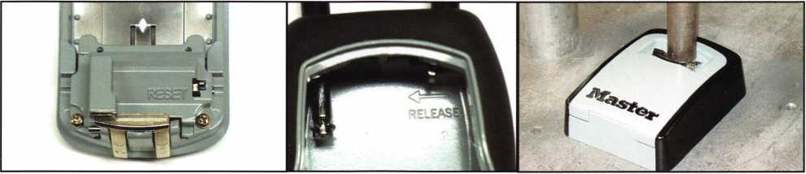

Keynotes • February 2003

A New Round Body

By Greg Perry, CML, CPS



Twenty or so years ago, American  
Lock Company introduced 2000,  
the first round-bodied, shackle-  
less padlock. Since then, a

few copies have been pro-  
duced. Three years ago,

American introduced  
the 2010 — a hard-  
ened steel version  
to complement  
the die-cast 2000.

The basic design  
remained the  
same. Now  
American has  
introduced a bet-  
ter round body.

In October, 2002,

American Lock  
started shipping  
the 2500 padlock. It  
is higher priced, but  
offers some features not  
found on the original.

Let’s take a look at both.

American improved the original 2000  
over the years. It originally had a  
screw concealed by some

putty, making it difficult  
to rekey Another  
drawback was the  
ability to pull the  
cylinder with a slide  
hammer. American  
addressed both  
issues, first by  
removing the  
putty from the  
screw, second by  
adding a couple of  
roll pins to either  
side of the keeper.  
It mated with their  
hasps to provide a  
great locking package.  
One method to prevent  
the slide hammer and  
also a drilling attack is to  
add angle iron or some other

block in the path to the cylin-  
der. As good as this padlock is,



Keynotes • February 2003



there was room for improvement. It is  
key retaining, and easily drilled if the  
cylinder was left exposed. American  
improved it with the introduction of  
the 2500.

The American Lock 2500 is non-key  
retaining, has a drill resistant shield over  
the plug, is easily rekeyed, and avoids  
slide hammer attacks. Photos 1, 2 and 3  
show the two padlocks side by side. The  
first thing you’ll notice is the location of

the cylinder. The 2000 and all the copies  
have the cylinder in the side of the body.  
The 2500 is installed from the back with  
only the keyway of the plug showing  
through the anti-drill shield. This shield  
should also prevent a slide hammer attack  
on the cylinder. Another difference is the  
amount of screws that must be removed  
to rekey the padlocks. Photo 3 shows the  
single screw of the 2000 and the five  
screws of the 2500 removed. At this  
point, the cylinder for the 2000 can be  
rekeyed or replaced. The 2500 requires a  
little more disassembly, (photo 4) there is  
also an easily lost spring, as it goes flying



KEY CODE SERVICE

With proper ID and  
security clearance

we can get codes  
for most cars.

Fax us at 1 -800-695-6810  
or call 1-800-741-4764  
for more information.

Keynotes • February 2003

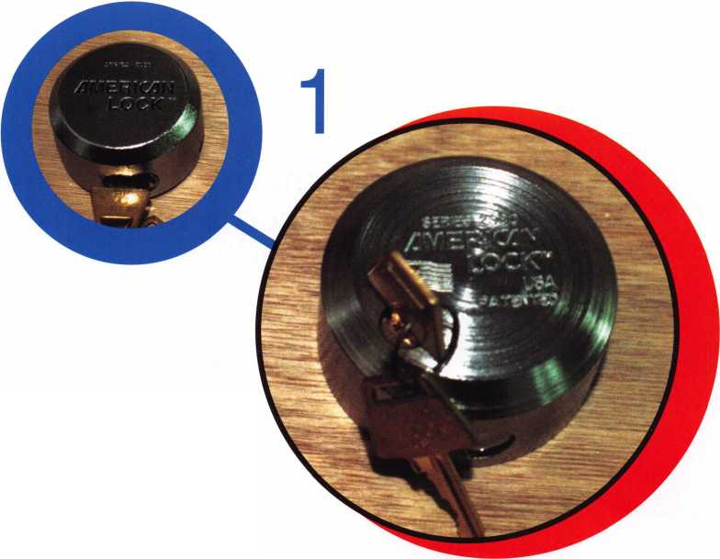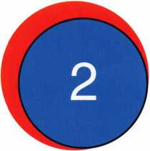

Now American has introduced a better round body

across the  
room if

you’re not  
careful. The  
spring is part

of what makes

non-key

retaining.

between the body and the slide. The

bolt has a cutout, and when the bolt is  
pushed in, the slide is pushed forward by  
the spring to capture the bolt. Unlocking  
is accomplished as seen in photo 5 by  
pushing the slide. This allows the bolt  
to spring open. The plug can then be  
turned back and the key removed. The  
cylinder of this lock is similar to other

cylinders in the American Lock line. They  
are available in both the standard PTKB-2

6-pin keyway as well as restricted keyways. The  
standard PKi pin kit or Master padlock’s 290 pin kit  
can be used to key these locks. Remember — if you’re  
using the Master pin kit, the pin numbers are off by  
one. Master designates their pins o through 7;  
American locks designates their pins as 1 through 8.  
So, an American 1 is equal to a Master o, American 2  
equals Master 1, and so on.

The 2500 is a quality padlock and adds a great lock to the round body line-up from the American Lock Company. Q



Keynotes • February 2003

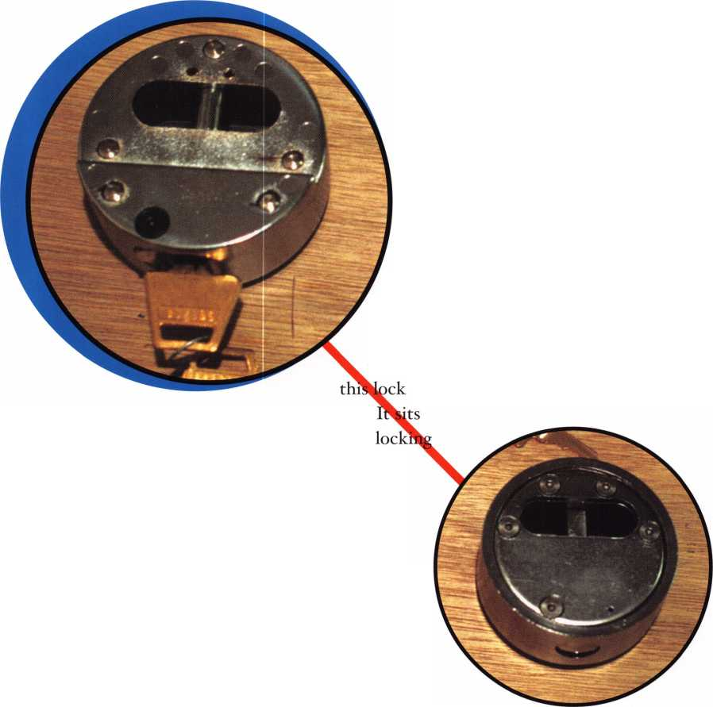

**New FREE ALOA Service**

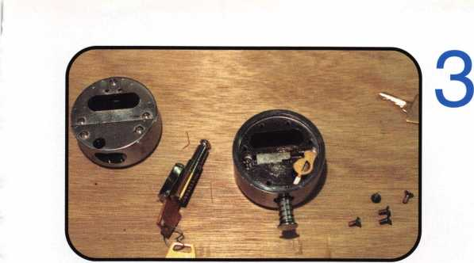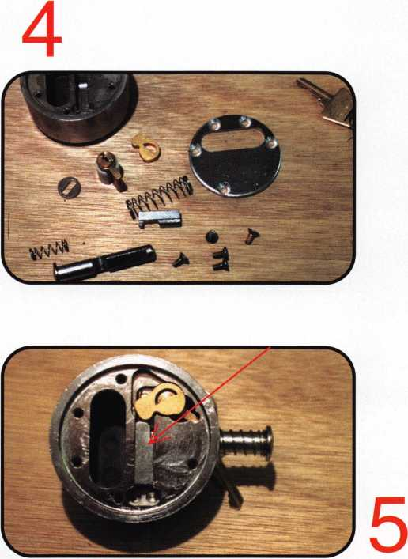

Get 100% of  
the value of  
bounced checks

There is NO CHARGE for this new ALOA service. We collect NSF checks you receive from your customers electronically through the U.S. banking system. You pay absolutely nothing. We successfully recover close to 85% of our clients’ NSF checks. Our service is done electronically. We receive a reasonable fee, set by state laws, from the NSF check writer. You do not have to write threat­ening letters or call bad check writers. It spares accidental bad check writers embarrassment.

**What You PONT Get:**

No sign up fees No monthly, quarterly or annual fees No return fees for 2nd & 3rd bounces No re-deposit fees for 2nd & 3rd bounces No court or collection agency fees No statement fees No monthly minimums No labor costs to you No equipment to buy or lease

No lengthy contracts No further action required by you

**What You DO Get:**

Fast, effective, FREE  
Receive 100% of all  
collected checks  
face value

Electronic debit of NSF  
writers account  
Paid within one week  
of collection  
User-friendly  
Non-intrusive for con-  
sumers

Spare accidental bad  
check writers embar-  
rassment

NEW - Track collection  
progress on our  
website

To Sign Up Contact:

CollectAChek, LLC • Customer Service:

Toll Free Phone: 888-584-5125 Website: [www.collectachek.com](http://www.collectachek.com) Email: [info@collectachek.com](mailto:info@collectachek.com)

**COLLECT**

**A CHEK**

Keynotes • February 2003

**2**

Keynotes • February 2003

Sometimes Hindsight is Not the Only 20/20 Vision

By Greg Perry, CML, CPS

There are times that offering a wide variety of prod­ucts has its downside, but often, it allows you to combine the best products into a far superior pack­age. Last month, I covered a new gun safe company (Safari Safe), and mentioned it was a last minute replacement for a burglarized safe. The original installation was performed at the end of 2001. Our customer runs an industrial chemical/mining plant. Large sections of the plant are left unsupervised during the night. After sustaining numerous losses over the course of about six months, they asked us for a quote on a video system. They realized the local law enforcement could not respond fast enough to catch the bad guys if an alarm was installed, so their only hope was to videotape the perpetrators in action, and hope the tapes showed the police a positive ID. After several meetings, sight surveys and discussions with our supplier, our substantial price quote was accepted. Part of the price was for a gun safe. What does a gun safe have to do with a video system?

Well remember — our primary concern was record­ing the perpetrators. The recording equipment needed to be there the next morning when the crime was discovered. We had to properly protect the equipment. Several of our customers have not heeded our advice and simply locked their VCR in an office, or some have used a sheet metal box. One

of our customers has had their VCR stolen 3 times. This time, we didn’t give the customer a choice; the price of the gun safe was included in the original quote, so it was part of our security plan from the beginning. Some of you may be asking why a gun safe? We could have used a large TL-rated unit, but felt a quality gun safe would adequately protect the recorder. The recorder we chose was a digital video recorder or DVR from Pelco. This is essentially a computer running Windows 98se with a large hard drive. It can store about four days worth of images before it starts recording over the top of the oldest data. Plus, it only records changes to the images. This means if overnight there is no movement or changes, then nothing new is recorded. The recorder is larger than the standard VCR, so we needed a fairly large safe to protect the recorder.

We chose a Sun Welding Calvary model # C34FL. This has a 3/8-inch door, 3/16-inch body, and it is fire lined with 5/8-inch drywall. As it was, we need­ed to turn the recorder sideways to have room for the cables from the cameras, and to the monitor and keyboard.

Once we started installing the equipment, the thefts stopped for 11 months. The morning of the break- in, the customer called at 5:30 a.m., the safe was torched and he wanted us out there to open the safe and replay the events of the night before. The bur-



Keynotes • February 2003

glar had  
been scared  
away by an  
employee  
coming early  
(about 5  
a.m.); nor-

This is what we saw when we arrived. mally they

Notice the torch lying on the ground. « ,

y y don’t start

work until

6:30. The culprit left his bounty in a trashcan by the  
door and ran. It should’ve been a simple matter of  
replaying the recording and the sheriff would go  
arrest him if they recognized him.

I called my boss and we drove out to the customer. As we walked in we saw the cutting torch set-up out­side the door. Looking into the room, we noticed the fire extinguisher chemical and the safe hinges on the floor. Apparently the burglar was concerned after he noticed smoke coming out of the safe he grabbed a fire extinguisher, discharging it into the safe. While I opened the safe my boss looked at the images from



This photo shows the  
remains of the manual  
and CDs for the system.  
The yellow powder is  
from the extinguisher  
chemical.

the DVR. The combination still worked, the lock bolt was retracted, and the 3-spoke handle turned, but the door would not open. The flame cutting had welded the door to the frame. Using a pry bar, we were able to open the door. The top shelf of the safe used to have the manual and CDs; now there was just a mess of ashes and ABC extinguisher chemical. Placing the DVR at the bottom of the safe probably saved it from the flame of the cutting torch. Placing it inside a gun safe prevented the burglar from stealing or destroying it. The DVR was saved.

Back to the safe itself. Sun Welding has offered to repair it at no charge, provided we deliver it to them. The hinges need to be replaced, and quite possibly, the whole door. The frame is damaged slightly form the torch attack, but should be easily repaired.

I removed the back panel of the door for a look around, and to be able to give you the specs on this safe.

The lock is mounted vertical down on a 1/2-inch hard- plate with a larger 1/4-inch plate between the door

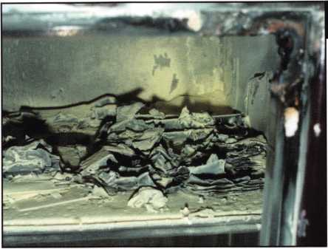

The DVR in the bottom of the safe has a good dusting of chemical residue.

Putting the recording  
unit in a decent safe  
showed great foresight.

Keynotes • February 2003

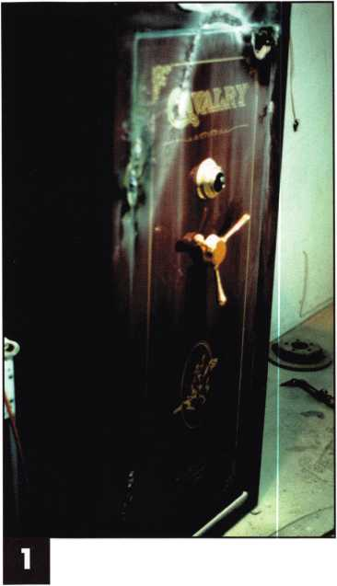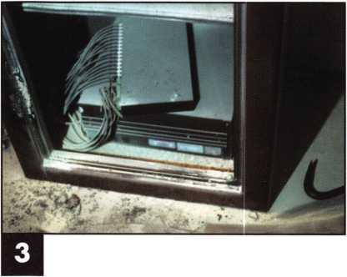

Sideview of door after we brought it back to our shop.

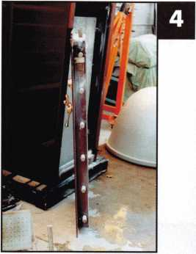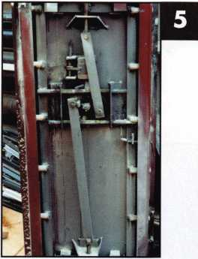

skin and lock mounting  
plate. It has 16 one-inch

bolts, 2 1/4 inches back from the face of the door  
attached to a four-way boltwork. From the top of  
the door, the bolts on the sides are placed as follows;

5 i/2=-inches, 14 1/4 inches 22 3/4 inches, 31 1/2 inches,  
40 inches, and 48 3/4 inches. The top and bottom  
bolts are from the opening edge, 6 5/8 inches and 17  
1/8 inches. A Sargent and Greenleaf 6730 mounted  
vertical down locks the handle cam from turning.

The handle turns counter-clockwise about 30 degrees  
to open. The relock is typical of Sun Welding; it is a  
spring-loaded rod with a washer welded to it. The  
relock plate has a flap extending off to retain the  
relock from firing. If you need to drill for the relock,  
move over about 3 1/8 inches right of the centerline of  
the lock and 1 7/8 inches down. This will allow you to  
lift the washer attached to the relock. The bolt detent

Bolts retracted.

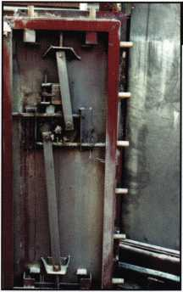

(or “bolt blocker” as Sun calls  
it) is a little different. It is the  
bent rod that sort of hinges to  
lift out of the way to allow the  
bolts to extend. Finally, if you  
wanted to side or top drill,  
measure back 2 1/2 inches

from the face 13 1/8 inches down, 11 1/8 inches from  
the opening edge. You need to be between the lock  
and the Sheetrock back cover. If coming from the  
top, you may need to drill through the upper bolt  
bar guide.



Bolts extended.

The safe did its job. We think the burglar left the safe after starting the fire and putting it out. He was seen outside with the trashcan, so it appears he wasn’t try­ing to finish the torch job. As of this writing, he still has not been caught. Putting the recording unit in a decent safe was great foresight. Q

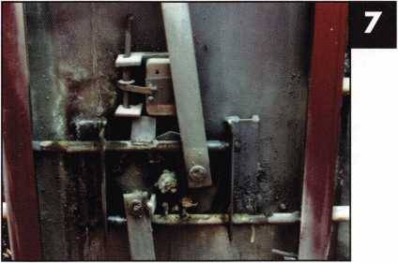

Close up of the lock area.

Close up of the bolt detent or bolt blocker. The bent rod piv­ots away from the strap on the bolt bar.

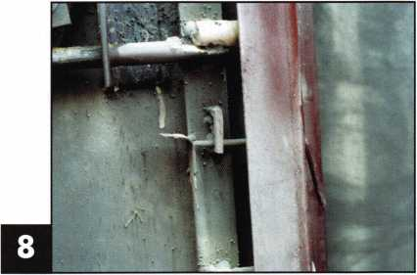

Keynotes • February 2003

Inside Johns Hopkins University:

The Land of 50,000 Keys

By: Claire L. Cohen, CML

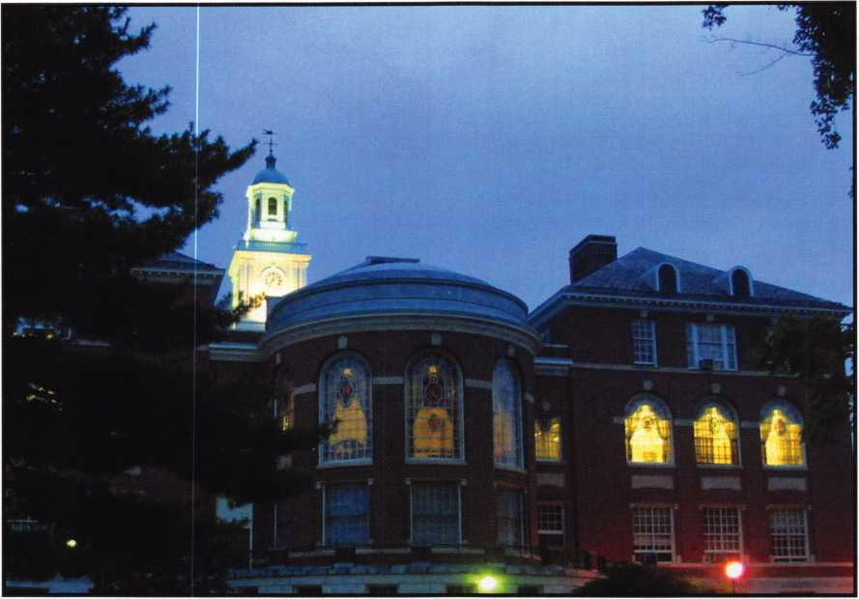

Johns Hopkins University was founded in Baltimore, Maryland in 1876. Today, the university has enrolled 18,000 full-time and part-time students on three major campuses in the Baltimore/Washington corri­dor, and has smaller facilities throughout the Baltimore/Washington area, in China and Italy Throughout all their campuses, the university employs more than 25,000 people in full-time, part- time and temporary positions.

Johns Hopkins University’s headquarters, Homewood campus, is a major landmark in downtown Baltimore. Students from all over the world attend classes at this

campus. At the Homewood campus and several nearby buildings, Lenny Podgorski, CFL, is the Locksmith Coordinator, responsible for the University locksmithing/security work in classrooms research laboratories, as well as the university’s huge administrative complexes.

Lenny is a veteran of the Baltimore City Police Department. During his 25-year career with the department, he specialized in patrol and initial inves­tigations. He was fascinated by scientific investiga­tion. He read everything he could about investigation, and accumulated many investigative scientific instru-

Keynotes • February 2003

ments. During his tenure, he took a locksmithing  
course from NRI, and completed the course with  
high honors. Recognizing his ability, Lenny was the  
only police officer in the Northeast Baltimore  
district who would be dispatched to open cars.

Lenny has many memories of opening cars, including  
an incident with a drunken man inside, with his foot  
on the accelerator!

Looking to the future, Lenny joined ALOA and the  
Maryland Locksmith Association (MLA). He regis-  
tered for many classes and seminars offered by both  
associations. He has a folder packed with class certifi-  
cates. Lenny says he pursued a locksmithing career  
“because I wanted to!” Upon retirement from

the Baltimore Police force in 1994, Lenny

found a home as an institutional lock-  
smith at Catonsville Community  
College in Catonsville, Maryland.

As a member of the Catonsville  
Community College Security  
Department, he was instrumental  
in putting in the ASSA brand  
throughout the entire campus. He  
continued to further his lock-  
smithing knowledge through addi-  
tional classes and “trial & error.”

When an ad appeared for a locksmith to

join Johns Hopkins University, he applied and  
was immediately hired. Initially, locksmithing was

under the Plant Operations Department and included  
university and housing, classrooms, research laborato-  
ries and administrative complexes. However, his cur-  
rent position, under the University’s Security  
Department, has eliminated housing.

The workday begins at 6 a.m., when Lenny checks Plant Operation’s Work Orders, e-mail and voicemail. His day ends at 2 p.m. The only other full-time mem­

ber of the locksmith team works from 9 a.m. to 5 p.m.  
This gives the university 11-hour weekday coverage.  
Overseeing the security work, Lenny is on call 24/7!  
Several locksmith contractors are on call on an emer-  
gency basis for evenings and weekends.

Lenny tries to do his administrative work early in the  
morning. Early in his day, he also tries to handle emer-  
gency situations, such as extracting broken keys.

Reviewing Work Order requests, he and his staff  
member may be asked to pin new locks, cut keys,  
adjust or repair door closers or exit devices.  
Prioritizing needs is essential for this busy

department.

Immediate repairs are why I am in the shop  
so early.” Administrative details include  
handling the billing, ascertaining which

department is financially responsible  
for repairs and replacement hard-  
ware.

Computers play a large role in the  
University Lock Shop. There is a  
database to track keys. Since  
February 1997, the University has  
traced 34,981 keys. (With University  
housing, there are close to 50,000

keys!) Locksmith software programs  
include master key systems, codes and man-  
ufacturer hardware cross-reference. Lenny uses

his computer for e-mail, word processing (primarily  
letters to vendors and university department memos),

and ordering of supplies.

Being prepared for emergency situations is part of the

job. Pre-pinned (painted yellow) emergency cores are

stocked in quantity. When a lock needs to be changed  
in a hurry, this stock of cores can be utilized tem-

porarily. This can be accomplished quickly and effi-

ciently. Several years ago on Christmas Eve, an

Lenny says he pursued a locksmithing career

“because I wanted

to!”

Keynotes • February 2003



Lenny Podgorski, CFL

entrance key was lost. This affected 16 entrance doors. Lenny said the painted yellow emergency cores were “popped in-fast.”

Johns Hopkins University has thousands of locks! The University primarily uses an interchangeable core sys­tem. They are moving from a 6-pin to a 7-pin system. There is a proliferation of different hardware brands- Best, Russwin, Corbin, Sargent, Falcon, Omni-“just about every lock you can think of.”

The Director of Security values Lenny’s input. He lis­tens to recommendations and attempts to help when­ever possible. Due to Lenny’s efforts, Johns Hopkins University uses the Intelikey access control system, which is designed around electronics, featuring intelli­gence in both the controller and the key He recom­mended this as a good choice for the university’s high- security needs, as the stand-alone function with unique keys can be reprogrammed quickly to grant or deny access to any combination of locks. Lenny likes flexibility of this system. Locks can be moved quickly and efficiently.

As there are only two full-time locksmiths on staff, with a huge number of locking devices to control, a roster of contractors contribute to the security of the

university. When safe work is necessary, an outside contractor is called to handle the job. Handling a large job, such as the upcoming Bloomberg Building with 500 cores, might shut down the lock shop, and prevent the day-to-day operations from running smoothly. Therefore, outside locksmiths are contract­ed to handle large-scale jobs.

The University Lock Shop maintains a good working relationship not only with local locksmiths, but with vendors. Keeping up-to-date with new products is critical to maintaining the Security Department.

Some of the professors believe that there is no need for high-security. “It’s a back and forth battle- convenience vs. security. We try to arrive at a happy medium.”

Yes, there are some routine problems to expect at the University:

* During exam weeks, students may put Superglue in the professors’ locks, hoping that the profes­sors won’t be able to get the exams out. Lock Shop to the rescue!
* Students have learned that a penny inserted “properly” near the latch will prevent the key from turning. Lock Shop to the rescue!

Computers play a large role in the University Lock Shop. There is a database to track keys. Since February 1997, the University has traced 34,981 keys.

CT1

Keynotes • February 2003

“It’s a back and forth battle—convenience vs. security

We try to arrive at a happy medium.”

• Students love paperclips. Courtesy of television and movies, students and professors alike think they can pick locks with them. Then the paperclip gets stuck in the lock. Lock Shop to the rescue!

To keep up with his education, Lenny has attended ALOA conventions each year, where he has taken classes. He is active with the Maryland Locksmith Association, where he was formerly Vice President.

He has taught classes for MLA on interchangeable core and forensics. “If they want the classes, I will teach them.”

Lenny is a member of The International Association of Investigative Locksmiths (IAIL) and is currently the Vice President. Lenny is proud of his CFL (Certified Forensic Locksmith) certification, which is

a designation awarded after satisfactory completion of certain relevant classes and of a written proficiency examination in the field of investigative locksmithing. Although no formal schedule has been set for classes, he has volunteered to teach a Forensic Locksmith class at the 2nd Annual IAIL convention this year.

Despite open-heart surgery (triple by-pass) at the end of July 2002, Lenny is back to work full-time, resum­ing a normal schedule. The university plans call for more buildings, and Lenny hopes “more electronics.” With thousands of locks, thousands of keys, and thou­sands of people working and attending classes at Johns Hopkins University’s main campus in Baltimore, this institutional locksmith is challenged to keep up with existing demands and to influence the future security of this growing University. Q

CyberLock Access Control for Your Entire Facility

[www.videx.com/lock47](http://www.videx.com/lock47)

CyberLocks replace standard mechnical locks and cylinders CyberLocks install without wiring CyberKeys® cannot be duplicated CyberLocks cannot be picked CyberKeys work only when you want them to

Joe Wilson

Abby Chaney

Pete Sussman

John Michaels

Evelyn Lefler

Juanita 8ank$

East Enhance

West Entrance

Records Room

Computer Room

West Entrance

Computer Room

03/20/2000 08:14:22 AM

03/20/2000 07:28:03 AM

03/20/2000 07:53;15AM

03/20/2000 08:00:03 AM

03/20/2000 08:12:16 AM

03/20/2000 08:18:52 AM

StatufTPff

Denied

Key Authorized

Out of Schedule

Key Authorized

Key Authorized

Key Authorized

03/20/2000 08:27:12 AM

Denied



• Audit report of every authorized and denied entry

**541**-**758-0521** • [sales@videx.com](mailto:sales@videx.com)

GC01663

Keynotes • February 2003

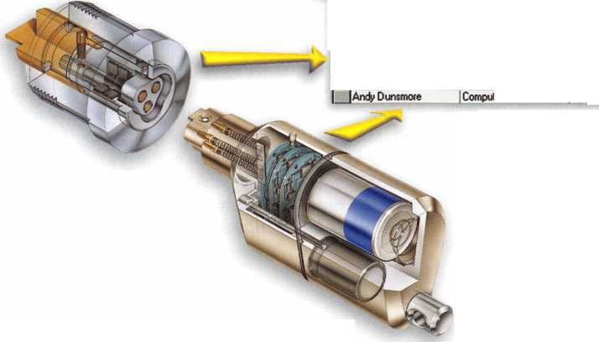

ALOA ATTENDS NATIONAL AUTOMOTIVE SERVICE TASK FORCE MEETING

Many of you involved in automotive locksmithing have seen an article in the latest issue of Mobil Electronics touting the automotive industries recent attempts to launch service infor­mation websites. ALOA Director of Public Policy, Tim McMullen along with Tom Seroogy and Mark Miller from Lockmasters attended the National Automotive Service Task Force (NASTF) meeting in Las Vegas to assess the OEM's willingness to release information and tools to the after-mar­ket through these websites. This meeting was in response to California which passed a law that requires this information to be made available to that state's after-market industry by March 2003. The OEM's have set this as their release date, although many of them said not all the information would available by March, and might be released afterwards.

This is because the European offices of many of the auto manufacturers refuse to make some information available. Before the task force meeting, Daimler Chrysler, Ford, GM, Honda, Isuzu, Kia, Nissan, Toyota, BMW, Mazda, Subaru, VW and Audi demonstrated websites where that informa­tion would be made available for a fee (24hr/l month/1 year). The average cost for one year of access was $2500. However, none of them had any information that would be useful to locksmiths. When we approached representatives about our situation, many of them had no immediate plans to make that information available, although Ford and Volkswagon said they we're looking at making that informa­tion available in the future. Nissan said they would never make that information available. It became clear that at this point they were just trying to get what the California Air Resource Board regulations (the regulations where "covered

persons" does not include locksmiths) requires of them, and that our issues were not even on their radar screens. But it also became clear that if there was information on the website, that they would want another layer of security.

Last Congressional session, the "Motor Vehicle Owner's Right to Repair Act" was introduced in the House by Rep. Joe Barton (R-TX), who is willing to re-introduce the bill this year. ALOA is attempting to have Rep. Barton, whose dis­trict is Ft. Worth, come to the headquarters in Dallas to dis­cuss the importance of this legislation for locksmiths. Tim McMullen is also attending the Aftermarket Legislative Summit, February 25-26th in Washington. If you will be available all day on Wednesday, February 26th to "work the Hill" with Tim, please contact him at 214-827-1701 xl6 or [tim@aloa.org](mailto:tim@aloa.org).

ALOA is also compiling Complaint Forms from locksmiths regarding this issue. The Complaint Form is tailored for a specific purpose: to obtain contact information for cus­tomers who have been inconvenienced because of lack of service. The greatest contribution that ALOA can make to getting the OEM's to release information is to bring stories from customers (not locksmiths) who have been stranded because they lost their keys and could not have a duplicate made by a locksmith for lack of transponder information. These forms will be used during Congressional hearings. We may even bring these customers in to testify!

These complaint forms are online at [www.aloa.org/news/legcom.cfm](http://www.aloa.org/news/legcom.cfm).



Keynotes • February 2003

**CONNECTICUT SB 14**

SUMMARY: Requires the licensing of locksmiths.

STATUS: 01/08/2003 INTRODUCED and Referred to General

Laws Committee

The text of the bill has not been released from legislative services, but has been assigned a bill number.

**MISSISSIPPI SB2367**

SUMMARY: Burglar alarms; license and regulate installation.

STATUS: 01/15/2003 INTRODUCED and Referred to Business

and Financial Institutions Committee The definition of Burglar Alarm reads, "a security system comprised of an interconnected series of alarm devices or components, including systems interconnected with radio frequency signals, which emits an audible, visual or electronic signal indicating an alarm condition and providing a warning of intrusion which is sent to a cen­tral station and requires a response by an emergency team such as police or fire personnel.

**NORTH DAKOTA HB1159**

SUMMARY: Relates to the jurisdiction of the private investigative and

security board. Gives vague definition on what consti­tutes "security services"

STATUS: 01/07/2003 INTRODUCED and Referred to Industry,

Business and Labor Committee 01/20/2003 Died in Committee

**SOUTH CAROLINA SB 186**

SUMMARY: Provides certain instances in which dead bolt locks

requiring a key for operation on both sides may be used on exit doors.

STATUS: 01/14/2003 INTRODUCED and Referred to Committee

on Judiciary

(Information current as of 1/15/2003)

Steve Young & Tech-Train loin

**IOCKMASTERS**

We're proud to announce the addition of Steve Young and Tech-Train to our organization.

Now more than ever, we’re bringing you the industry's best selection of products and an  
unrivaled source of automotive expertise.

The products and support you've come to trust from both Lockmasters and Tech-Train are now all  
available at Lockmasters. We're your one-stop shop for all your automotive locksmithing needs

OCKMASTERS

*2003 ‘DctCe\**

CL'Weekend*

Lockmasters is Proud To Welcome To Our Pit Crew

March 8-9

April 26-27^^^^^ May 17-18 J June 21-22P August 2-3 September 6-'

October 11-12

*'flew*

**LOCKMASTERS**

NCORPORATED

t-recjh 800.654.0637

' [www.pureauto.comwww.techtrainproductions.com](http://www.pureauto.comwww.techtrainproductions.com)

2003*.*

Keynotes • February 2003

**3**

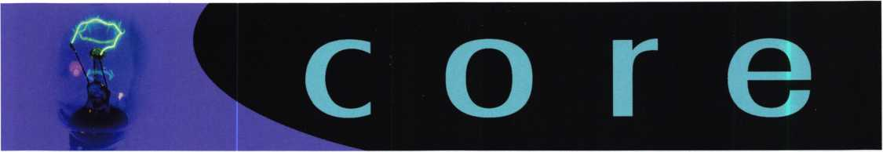

LETTERS TO THE EDITOR

Dear Editor:

I read your article on "X-0" locks (November 2002 issue of Keynotes) with great interest. In the past five years, I have installed six X-07's and two X-08's at one government con­tractor site. All were CDX-0's, actually, for controlled access to secure work areas.

The article mentions the plastic motor gear, which retracts the bolt. I have had one of the X-08's fail because the gear teeth were sheared by their counterparts. Fortunately, the other lock was on the opposite end of the room, allowing access to the rear of the lock. Mas-Ham tech people knew immedi­ately when I called, and I got the replacement parts very quickly.

The culprit was a strike/bolt alignment that put too much pressure on the gear connection. The people using that door did not report that it was giving them a problem until the lockout. That lock was working smoothly when it was installed, but some movement of the door/frame/wall caused it to misalign.

The strike bolt fit on this device is too critical for a door in the average workplace. I am now careful to open up those cast strikes to allow for such wear and tear.

Also, hollow metal doors are "not flat." That door may be 1 3/4 inches thick, at the edge, but they tend to puff outward as they go toward the middle. This makes dial installation dif­ficult, at best. These doors are also affected by temperatures that can affect the fit of the strike. Three of my previously- mentioned X-07's are on solid core wood doors, and they installed much easier, more smoothly and I've never had to go back to work on them. I have had to make adjustments on all of those on HM doors.

I have not yet done an X-09, but I'm glad to see that they went back to left/right/left dialing (I couldn't seem to pro­gram my hand to only go one way!).

Just a few observations. The article [written by Greg Perry, CML, CPS] was very enlightening and very helpful for those who have or have not yet worked with this lock. Thanks, Bob Roman, La Vale, MD

ATTENTION ALL ALOA MEMBERS!

This month is "sweeps" month for all the television networks. One thing they enjoy doing at this time of the year are their news team's "Investigative Reports". Many times this includes a "sting operation" where they will call a locksmith for a lockout to catch them not asking for identification. DON'T BE FOOLED!!! If you get called this month for a lockout, make sure you follow ALOA's Positive ID Policy - everyone will have their 15 minutes of fame sometime, but you probably don't want your's this way!

ALOA's POSITIVE ID POLICY:

* ALOA locksmiths are instructed to use the following posi­tive identification policy when servicing lockouts:
* Notify Caller. When a call comes in to request lockout services, ask the caller if he/she has identification and authority to open the lock.
* Complete Form. Upon arrival at the job site, the lock­smith should complete an Authorization Form that asks for the name, address, phone number, identification number and property description from the customer.
* Verify I.D. Verify the customer's photo-identification card and compare it to the information provided by the cus­tomer. If no photo-ID card is available, ask for some other reasonable form of ID.
* Verify Authority. The locksmith should inquire as to what authority the customer has to open the lock, and request to see any reasonable and appropriate evidence that could verify the authority. This may be impossible in some cases.
* Ask for Signature. Ask the customer to sign the Authorization Form, which should contain a statement that (a) the information given by the customer is correct,

1. the customer has the authority to open the lock, and
2. the customer shall indemnify and hold harmless the locksmith against liability.

* Optional Last Resort. If you have any suspicions that the customer is giving false information or does not have authority to open the lock, say that you will be happy to open the lock provided a law enforcement officer

is present. If the customer agrees, call the police; if not, leave.

* File the Form. Keep the Authorization Form on file for a reasonable period of time.

Keynotes • February 2003

ALOA GRIEVANCE POLICY

According to the Bylaws of the Associated Locksmiths of America, Inc., Article III, G. Section 6:

A member may be censured, suspended or removed by a two- thirds vote of the Board if he has violated the Charter, Code of Ethics or the ALOA Bylaws. Charges must be presented in writ­ing to the Grievance Committee. Action shall occur only after the member complained against has been given an opportunity to for defense before the Board. There is the right of appeal.

To file a grievance, the official ALOA Grievance form [available on our Web site, [www.aloa.org](http://www.aloa.org), or by calling toll free 800/532-ALOA] must be filled out, signed and returned to the Associated Locksmiths of America, Inc., before any action can be taken regarding your complaint. The form, when completed and returned, will be forwarded to the entire Grievance Committee and read at their next meeting.

The ALOA Grievance Committee is the direct link between the membership and the Board of Directors, and is available to mediate disputes between ALOA members and disputes that involve other persons or companies. Be advised that personal feuds and/or vendettas of unsubstantiated accusations will be rejected by the committee. The person you have filed a griev­ance against will be notified of the nature of the complaint and will be invited to respond.

For additional information, contact membership services toll free at 800/532-ALOA, or by e-mail at [membership@aloa.org](mailto:membership@aloa.org).

LET US KNOW!

If you have an opinion to offer on ALOA, the state of the indus­try, or life in general, we want to know about it! Submissions to the "Mailbox" section of Keynotes are printed on a space-avail- able basis. Write to: "Letters to the Editor"; ALOA; 3003 Live Oak Street; Dallas, TX, 75240; FAX 214/827-1810; e-mail: [editor@aloa.org](mailto:editor@aloa.org).

NEED HELP?

At ALOA, we want to make sure you are getting as much bang for your membership dues buck as we are able to give you. If you have had problems getting membership services, or have a question regarding member services, please contact Bill Gibson, executive director, at 800/532-2562, or e-mail: [charlie@aloa.org](mailto:charlie@aloa.org).

IN MEMORY: FRANK LUNGA

Frank Lunga (member number 26498) recently passed away. Frank worked at East Coast Locksmithing from 1987 until the present. He was an extra-good person who was well-loved by the people who knew him. He is survived by his wife, Leslie; son, Frank Jr., and daughter Audrey. His freinds Bob and Dawn Mandel will miss him.

TUMMY RUB GETS MOTOR RUNNING

From the Vancouver Province Newspaper,

Tuesday, December 21, 2002

London mother Amanda Webster, 34, who was stranded when her teething baby ate a vital part of the car key, managed to start the engine by pressing him close to the steering wheel.

One-year old Oscar Webster had swallowed a ill-sized radio Transponder - a coded electronic chip security device - while playing with her keys in the back of the car.

Thinking that her car had broken down, Webster called the automobile association, which dispatched Keith Scott, 37. At first, he thought that the battery was flat. "Then I noticed that part of the key was missing," Scott said. "So we looked around the car. Oscar's mother had let him play with the keys while she loaded the shopping.

All of a sudden, it dawned on me. Mrs. Webster told me that he had been sucking the keys and we realized he might have swal­lowed part of it.

Assuming the Transponder should work no matter how unusual its surroundings, Scott suggested holding Oscar close to the steering column as the key was inserted.

"She sat him on her lap and made sure that his tummy was pressed up against the wheel. She turned the key and the car started."

Oscar was none the worse for the experience and, when nature took its course, the chip was recovered still in working order.

New Certifications

CRLs

Lynn Seward Atasca, TX

CORRECTIONS for December 2002 issue:

Timothy Horton was listed as a new CRL and should have been listed as CML.

Clifford Shafer was also listed as a new CRL and should have been listed as a CPS.



Keynotes • February 2003



EMPLOYMENT

EXPERIENCED LOCKSMITH

Established and expanding company in central NJ is seeking experienced help in residential/commercial/auto/access control/safe work. Top pay for top mechanics, along with medical, dental, paid vacation, two days off per week, and no night calls.

Apple Locksmith • 4030 Route 9 South Morganville, NJ 07751 • 732/970-1500 or fax resume to 732/970-9725 (attn: Andy or Jack)

AUTOMOTIVE LOCKSMITH WANTED

Relocate to South Florida and throw away your deadbolts and three keys for a dollar.

We run over 300 calls per week. You must own a truck with tools and code equipment to cut all foreign and domestic keys. You can earn $800 to $1500 per week. South Florida Lock and Safe. 800/9280-2926. Please if no truck or tools, no calls.

LOCKSMITH WANTED

Rapidly growing Lock and Safe business in N. W. PA seeks experienced locksmiths in any or all phases of the industry. Our work is 90% Commercial, Institutional and Financial Institutions. We are a resort community offering Boating, Hunting, Fishing and numerous Golf Courses. If you would like to experience Rural living, come join us.

Contact:Tom Uhlig, CPS Uhlig Lock & Safe • (814) 724-2255 (814) 724-1687 fax e-mail: [lockdoctor@alltel.net](mailto:lockdoctor@alltel.net)

LOCKSMITH NEEDED FOR A CONTRACT ASSIGNMENT

A nationwide security services provider is look­ing for a locksmith to perform basic assign­ments. This will include the installation and replacing of locks at customer sites.

Strong mechanical aptitude and proficiency with hand tools required.

This individual must be a fast learner and have the ability to complete assigned tasks with min­imum supervision.

Must have a valid drivers license. Experience as a locksmith or apprentice would be helpful.

Location: New York metropolitan area

Scheduled Hours: Typical business hours, Monday through Friday. There may be some occasional overtime based on projects needs.

Travel: Local travel throughout the 5 boroughs and Nassau / Suffolk.

Start Date / End Date: Interviews in early February with the client and a project start date of February 24th (approx.)

Additional Information: All candidates must have verifiable work experience. Criminal and credit background checks will be conducted.

Contact Information: Lori Useche, Technical Recruiter, IT Network Consultants, Inc., (631) 757-2400 ext.228, Fax: (631) 757-8605 [Luseche@itnc-usa.com](mailto:Luseche@itnc-usa.com) [www.itnc-usa.com](http://www.itnc-usa.com)

BUSINESS FOR SALE

BUSINESS FOR SALE

32 years. Need to retire. Will sell business with or without 1 800 square foot building on major downtown street. Only locksmith in county. Growing west Texas area. Call 915/336-3278 and ask for Dean.

BUSINESS FOR SALE

Looking to relocate to sunny Arizona. Established in same location for over 14 years. Profitable Lock & Safe business with service and retail location. Good client base. Reasonably price to right person. E-mail inquiries to [Lockbizaz@aol.com](mailto:Lockbizaz@aol.com) or fax to 602- 870-8505.

WANTED TO BUY/SELL

NEED AUTO INFO?

Do you do exotic autos? If you are called to

provide keys for a Panoz Espirante, Here is

contact info for the company - they provided

key codes, transponder codes and are very

helpful: Panoz Auto Development Company

1101 Highway 124

Hoschton, Georgia 30548

Tel: (770) 867-4796

Toll Free: 1-888-GOPANOZ (467-2660)

Fax: (770) 307-1714

E-mail: [panozauto@panozauto.com](mailto:panozauto@panozauto.com)

Classified Advertising Policy

Classified advertising space is provided free of charge to ALOA members, and for a fee of $.60 per word, $ / 5 minimum for non-members. Classified ads may be used to advertise used  
merchandise and overstocked items for sale, "wanted to buy" items, business opportunities, employment opportunities/positions wanted and the like. Members or non-members wishing to  
advertise services or new merchandise for sale may purchase a "Commercial Classified Ad," for a fee of $1.30 per word, with a minimum of $40. Each ad will run for two issues. For  
blind boxes there is a $5 charge to members and non-members. All ads must be submitted in writing to the ALOA office by the fifteenth of the month, two months prior to issue date. Send  
to Keynotes Classifieds, 3003 Live Oak St., Dallas TX 75204-6186. ALOA reserves the right to refuse any classified advertisement that it deems inappropriate according to the stated pur-  
pose of the classified advertising section.

Keynotes • February 2003

FOR SALE

5 Schlage A53PD ORB 626 Entry locksets @ $20 each

1. US1760BF DL door closers @ $50 each 2 US 1735 AL door closers @ $50 each

1 US 1703 DL door closer @ $25 1 US 1743 DL door closer @ $30 1 US 1744 DL door closer @ $30 1 Monarch #19 Rim Exit Panel Device 36" AL @ $75 1 US2870 AL Rim Panic Device @ $100 Contact: Builders Hardware Sales and Service Phone: 610/495-5465 e-mail: [barlocks@juno.com](mailto:barlocks@juno.com)

OVERSTOCK, NEW VON DUPRIN

1. E99K US26 3' $ 525 ea.
2. 22TP F 3' 689 $250 ea.
3. 3347TL 3' US26D $720 ea.

I have more 9947,3347,2227,9975 for sale.

Please call Kevin at 915-553-3145 or e mail: [reddog2501@excite.com](mailto:reddog2501@excite.com) .

NEED CASH?

Have you recently sold your locksmith business, or are you selling it now? We can give you a lump sum of cash now for all or a portion of your remaining payments. RED OAK FUNDING. 630/483-0335.

BARGAIN OF THE CENTURY FOR SALE

* 4-drawer fireproof file cabinets, all 350 degree, one hour, perfect condition
* 5 Fireking with Medeco locks
* 3 Schwab
* 1 Hercules by Meilink
* 1 Diebold
* 1 Meilink

For further details, call Allied Locksmiths (954/704-8215), or e-mail to [alliedlock@aol.com](mailto:alliedlock@aol.com).

FOR SALE

Fort Lock Tubular Model KM#7, llco Model 21 83HM, llco Model 2585, Jenson Micro Dial Model 1275. Plus, HUGE octagon rotat­ing cabinet loaded with merchandise. ALL PRICED TO SELL! 847- 251-2541. Central Time- evening calls are best. Ask for Jake

WHOLESALE SAFE DEPOSIT LOCKS

Allied, Diebold, Herrin Hall & Mavin, llco, Lefabure, Mosler, Precission, S&G, Security Corp., Yale. Locks from early 1900s to current. Call or e-mail for lock type and pricing sheet. Quantity discouts. Call WBI (888)329-7265 or (954)484-2404 or [sales@wbi.us](mailto:sales@wbi.us).

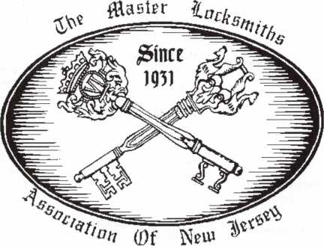

MLANJ 2003  
Annual Convention

(Classes, Trade Show, and Banquet)

April 2nd thru April 6th

Somerset, New Jersey

For More Information:

PO Box 2441

Morristown, NJ 07962-2441  
Fax 973-538-1588

Or visit our web site at

[www.MLANJ.org](http://www.MLANJ.org)



Keynotes • February 2003



Distributor

ADI Inc.

Phone: 631-692-1000 Fax: 631-692-3011

Accredited Lock Supply Co.

Phone: 201-865-5015 Fax: 201-865-0030 [www.acclock.com](http://www.acclock.com)

Ace Lock & Security Supply

Phone: 908-688-7666 Fax: 908-688-2442 [www.acelock.com](http://www.acelock.com)

Action Hardware Inc.

Phone: 800-662-6695 Fax: 800-930-2329

Andrews Wholesale Lock Supply

Phone: 717-272-7422 Fax: 717-274-8659 [www.andrewslock.com](http://www.andrewslock.com)

Boyle & Chase Inc.

Phone: 800-325-2530 Fax: 800-205-3500 [www.boyleandchase.com](http://www.boyleandchase.com)

Chinrose International

Phone: 503-357-7553 Fax: 503-357-5522 [www.chinrose.com](http://www.chinrose.com)

Clark Security Products

Phone: 800-854-2088 Fax: 619-974-5284 [www.clarksecurity.com](http://www.clarksecurity.com)

Cook's Building Specialties

Phone: 505-883-5701 Fax: 505-883-5704

Dire's Lock & Key Company

Phone: 303-294-0176 Fax: 303-294-0198

Direct Security Supply, Inc.

Phone: 800-252-5757 Fax: 800-452-8600

Doyle Security Products

Phone: 800-333-6953 Fax: 612-521-0166 [www.doylesecurity.com](http://www.doylesecurity.com)

Dugmore and Duncan, Inc.

Phone: 888-384-6673 Fax: 888-329-3846

E. L. Reinhardt Co., Inc.

Phone: 800-328-1311 Fax: 651-481-0166 [www.elreinhardt.com](http://www.elreinhardt.com)

Ewert Wholesale Hardware

Phone: 800-451-0200 Fax: 708-597-0881

Fairway Supply, Inc.

Phone: 214-350-0021 Fax: 214-352-4299 [www.fairwaysupply.com](http://www.fairwaysupply.com)

Foley-Belsaw Company

Phone: 800-821-3452 Fax: 816-483-5010 [www.foley-belsaw.com](http://www.foley-belsaw.com)

Fried Brothers Inc.

Phone: 800-523-2924 Fax: 215-592-1255 [www.fbisecurity.com](http://www.fbisecurity.com)

H L Flake Co.

Phone: 800-231-4105 Fax: 713-926-3399 [www.hlflake.com](http://www.hlflake.com)

H.S. & S. Wholesale Distrib.

Phone: 313-342-6777 Fax: 313-342-7580

Hans Johnsen Company

Phone: 214-879-1550 Fax: 214-879-1530 [www.hjc.com](http://www.hjc.com)

Hardware Agencies, Ltd.

Phone: 416-462-1921 [www.hardwareagencies.com](http://www.hardwareagencies.com)

Howard Keys

Phone: 704-509-4944 Fax: 704-509-6248 www. howa rd keys. com

IDN Incorporated

Phone: 817-421-5470 Fax: 817-421-5468 [www.idn-inc.com](http://www.idn-inc.com)

Intermountain Lock & Supply

Phone: 800-453-5386 Fax: 801-485-7205 [www.intermountainlock.com](http://www.intermountainlock.com)

Jo Van Distributors

Phone:416-752-2238 Fax: 416-752-7282 [www.jovanlock.com](http://www.jovanlock.com)

Lockmasters, Inc.

Phone: 859-885-6041 Fax: 859-885-7093 [www.lockmasters.com](http://www.lockmasters.com)

Locks Company

Phone: 800-288-0801 Fax: 305-949-3619

Locksmith Ledger International

Phone: 770-886-0800 Fax: 770-889-7703 [www.lledger.com](http://www.lledger.com)

M. Zion Company

Phone: 2 1 2-349-8677 Fax: 212-964-0495 [www.mzion.com](http://www.mzion.com)

McDonald Dash Locksmith Supply

Phone: 800-238-7541 Fax: 901-366-0005 [www.mcdonalddash.com](http://www.mcdonalddash.com)

McManus

Locksmith Supply, Inc.

Phone: 704-333-9112 Fax: 704-332-8664

Monaco Lock Co.

Phone: 800-526-6094 Fax: 800-845-5625 [www.monacolock.com](http://www.monacolock.com)

Omaha

Wholesale Hardware

Phone: 800-238-4566 Fax: 402-444-1664 [www.omahawh.com](http://www.omahawh.com)

Phoenix Safe International LLC

Phone: 765-483-0954 Fax: 765-483-0962 [www.phoenixsafeusa.com](http://www.phoenixsafeusa.com)

Professional Business Products

Phone: 248-360-3979 Fax: 248-360-3982 [www.professionalbusinessprod- ucts](http://www.professionalbusinessprod-ucts).

RA-Lock Company

Phone: 972-775-6301 Fax: 972-775-6316 [www.ralock.com](http://www.ralock.com)

SecureRite.Com

Phone: 800-241-3930 Fax: 858-974-5269 [www.SecureRite.Corn](http://www.SecureRite.Corn)

Security House

Phone: 905-669-5300 Fax: 905-660-6313 [www.securityhouselock.com](http://www.securityhouselock.com)

Sentry Security Fasteners

Phone: 309-693-2800 Fax: 800-693-2872

Somerset Security Products

Phone: 800-881-5206 Fax: 800-206-9949

Southern Lock and Supply Co.

Phone: 727-541-5536 Fax: 727-544-8278 [www.southernlock.com](http://www.southernlock.com)

Stone & Berg Wholesale

Phone: 800-225-7405 Fax: 800-535-5625

The Locksmith Store Inc.

Phone: 847-364-5111 Fax: 847-364-5125 [www.locksmithstore.com](http://www.locksmithstore.com)

Timemaster Inc.

Phone: 859-259-1878 Fax: 859-255-0298 [www.time-master.com](http://www.time-master.com)

Top Notch Distributors, Inc.

Phone: 800-233-4210 Fax: 800-854-4146 [www.4topnotch.com](http://www.4topnotch.com)

U.S. Lock Corp.

Phone: 800-925-5000 Fax: 800-338-5625 [www.uslock.com](http://www.uslock.com)

Manufacturer

A & B Safe Corporation

Phone: 800-253-1267 Fax: 856-863-1208 [www.a-bsafecorp.com](http://www.a-bsafecorp.com)

ABUS Lock Company

Phone: 800-352-2287 Fax: 602-516-9934 [www.abus.com](http://www.abus.com)

Abloy Door Security

Phone: 800-465-5761 Fax: 514-335-0430 [www.abloy.com](http://www.abloy.com)

Adams Rite Mfg. Company

Phone: 800-872-3267 Fax: 800-232-7329 [www.adamsrite.com](http://www.adamsrite.com)

Adesco Safe Mfg. Company

Phone: 800-821-6803 Fax: 562-408-6427 [www.adesco.com](http://www.adesco.com)

Adrian Steel Company

Phone: 800-677-2726

Fax:517-265-5834

[www.adriansteel.com](http://www.adriansteel.com)

Alarm Lock Systems Inc.

Phone: 800-252-5625

Fax:516-789-3383

[www.alarmlock.com](http://www.alarmlock.com)

All Five Tool Company, Inc.

Phone: 860-583-1691 Fax: 860-583-4516 [www.all5tool.com](http://www.all5tool.com)

American Lock Company

Phone: 708-534-2000 Fax: 708-534-0531 [www.armericanlock.com](http://www.armericanlock.com)

American Security Products

Phone: 909-685-9680X1083 Fax: 909-685-9685 [www.amsecusa.com](http://www.amsecusa.com)

BWD Automotive

Phone: 334-872-6524 Fax: 334-874-6011 [www.bwdautomotive.com](http://www.bwdautomotive.com)

Baldwin Hardware

Phone: 610-796-4012 Fax: 610-796-4493 [www.baldwinhardware.com](http://www.baldwinhardware.com)

Be-Tech Security Systems Ltd.

Phone: 852-231-67447 www. be-tec h. co m. h k Buddy Products

Phone: 800-886-8688 Fax: 312-733-8356 [www.buddyproducts.com](http://www.buddyproducts.com)

COMPX Security Products

Phone: 864-297-6655 Fax: 864-297-9987 [www.nclnet.com](http://www.nclnet.com)

Curtis Industries,

A Barnes Distr.

Phone: 800-555-5397 Fax: 800-867-6020 [www.curtisindustries.com](http://www.curtisindustries.com)

D&D Technologies (USA), Inc.

Phone: 714-677-1300 x292 Fax: 714-677-1299 [www.ddtechusa.com](http://www.ddtechusa.com)

DETEX Corporation

Phone: 800-729-3839 Fax: 830-620-6711 [www.detex.com](http://www.detex.com)

DORMA

Architectural Hardware

Phone: 717-336-3881 Fax: 717-336-3500 [www.dorma-usa.com](http://www.dorma-usa.com)

Don-Jo Manufacturing, Inc.

Phone: 978-422-3213 Fax: 978-422-3467 [www.don-jo.com](http://www.don-jo.com)

Door Controls International

Phone: 800-742-3634 Fax: 800-742-0410 [www.doorcontrols.com](http://www.doorcontrols.com)

ESP Lock Products Inc.

Phone: 978-562-3481 Fax: 978-562-9859

FireKing Security Products

Phone: 800-457-2424 Fax: 800-896-6606 [www.fireking.com](http://www.fireking.com)

HES, Inc.

Phone: 623-582-4626 Fax: 623-582-4641 [www.hesinnovations.com](http://www.hesinnovations.com)

HPC, Inc.

Phone: 847-671-6280 Fax: 847-671-6343

[www.hpcworld.com](http://www.hpcworld.com)

Hongtai Lock Co. Ltd.

Phone: 137-238-1414 Fax: 208-793-3856

INTELLIKEY Corp.

Phone: 800-226-0703 Fax: 321-724-0811 www. i ntel I i key.com

llco Unican

Phone: 252-446-3321 Fax: 252-446-4702 [www.kaba-ilco.com](http://www.kaba-ilco.com)

Jet Hardware Mfg., Co.

Phone: 718-257-9600 Fax: 718-257-0973 www. j etkeys. com

KABA High Security Locks

Phone: 860-621-3601 Fax: 860-621-9727 [www.kabausa.com](http://www.kabausa.com)

KEY-BAK/West Coast Chain Mfg.

Phone: 909-923-7800 Fax: 909-923-0024 [www.keybak.com](http://www.keybak.com)

Keynotes • February 2003

associate

members

Keri Systems Inc.

Phone: 408-451-2520 Fax: 408-441-0309 [www.kerisys.com](http://www.kerisys.com)

Knaack Manufacturing Co.

Phone: 800-456-7865 Fax: 815-459-9097 [www.weatherguard.com](http://www.weatherguard.com)

LAB Security

Phone: 800-243-8242 Fax: 860-583-7838 [www.labpins.com](http://www.labpins.com)

LCN Closers/

Div. of Ingersoll

Phone: 815-875-3311 Fax: 815-879-1497 [www.lcnclosers.com](http://www.lcnclosers.com)

La Gard Inc.

Phone: 310-325-5670 Fax: 310-325-5615 [www.lagard.com](http://www.lagard.com)

Lucky Line Products, Inc.

Phone: 858-549-6699 Fax: 858-549-3241 [www.luckyline.com](http://www.luckyline.com)

M.A.G. Security

Phone: 714-891-5100 Fax: 714-892-6845 [www.magsecurity.com](http://www.magsecurity.com)

MARKS, U.S.A.

Phone: 516-225-5400 Fax: 516-225-6136 [www.marksusa.com](http://www.marksusa.com)

MARRAY Enterprises

Phone: 408-970-0213 Fax: 408-970-8767 [www.marray.com](http://www.marray.com)

MCS Communication Sys­tems

Phone: 514-444-2040 Fax: 514-444-2029 [www.mcscommunication.com](http://www.mcscommunication.com)

MMD, Inc.

Phone: 865-428-3611 Fax: 865-453-4136

MUL-T-LOCK USA, Inc.

Phone: 800-562-3511 Fax: 973-778-4007 [www.mul-t-lock.com](http://www.mul-t-lock.com)

Master Lock Company

Phone: 414-444-2800 Fax: 414-444-0322 [www.masterlock.com](http://www.masterlock.com)

Medeco Security Locks

Phone: 540-380-5000 Fax: 540-380-5010 [www.medeco.com](http://www.medeco.com)

NKL Industries Inc.

Phone: 800-528-9900 Fax: 757-485-0271 [www.nklindustries.com/prod- ucts.NK](http://www.nklindustries.com/prod-ucts.NK)

Pro Steel

Phone: 801-373-2385 Fax: 801-373-2399 [www.prosteel.us](http://www.prosteel.us)

ROFU International Corp.

Phone: 800-255-7638 Fax: 253-922-1728 [www.rofu.com](http://www.rofu.com)

Rutherford Controls Int'l. Co.

Phone: 757-427-1230 Fax: 757-427-9549 [www.rutherfordcontrols.com](http://www.rutherfordcontrols.com)

STRATTEC Security Corp.

Phone: 414-247-3415 Fax: 414-247-3692 [www.strattec.com](http://www.strattec.com)

Sargent & Greenleaf, Inc.

Phone: 859-885-9411 Fax: 859-885-3063 [www.sargentandgreenleaf.com](http://www.sargentandgreenleaf.com)

Sargent Manufacturing Co.

Phone: 203-562-2151 Fax: 203-776-5992 [www.sargentlock.com](http://www.sargentlock.com)

Schlage Lock Co.

Phone: 719-264-5300 Fax: 719-264-5382 [www.schlagelock.com](http://www.schlagelock.com)

Schwab Corp.

Phone: 765-447-9470 Fax: 765-447-8278 [www.schwabcorp.com](http://www.schwabcorp.com)

Securitron Magnalock Corp.

Phone: 775-355-5625 Fax: 775-355-5636 [www.securitron.com](http://www.securitron.com)

Security Door Controls

Phone: 805-494-0622 Fax: 805-494-8861 [www.sdcsecurity.com](http://www.sdcsecurity.com)

Security Solutions

Phone: 405-376-1600 Fax: 405-376-6870 [www.securitysolutions-usa.com](http://www.securitysolutions-usa.com)

Sully Tools Inc.

Phone: 703-689-3416 Fax: 703-787-0869 [www.sullytools.com](http://www.sullytools.com)

Sun Safes Manufacturing Co.

Phone: 823-194-59300 Fax: 823-194-59400 [www.eaglesafes.com](http://www.eaglesafes.com)

Taylor Security & Lock

Phone: 301-948-7670 Fax: 301-948-1029 [www.taylorsecurity.com](http://www.taylorsecurity.com)

Taymor Industries, Inc.

Phone: 800-388-9887 Fax: 800-288-8133

Trine Access Technology

Phone: 718-829-2332 Fax: 718-829-6405 [www.trineonline.com](http://www.trineonline.com)

Victor E-lok, Inc.

Phone: 949-786-0133 Fax: 949-786-0133 Videx Inc.

Phone: 541-758-0521 Fax: 541-752-5285 [www.videx.com](http://www.videx.com)

W-LOK Corporation

Phone: 616-355-4015

Fax:616-355-4295

[www.wlokcorp.com](http://www.wlokcorp.com)

Yale Security Group, Inc.

Phone: 800-438-1951 Fax: 800-338-0965

Service

Organization

1-800 Locksmith 1994 Inc.

Phone: 800-562-5764 Fax: 718-236-4504 www. 1 800locksmith.net

Allstate Insurance Com­pany

Phone: 800-859-0247 Fax: 847-326-7509 [www.allstate.com](http://www.allstate.com)

Emergency Road Service Inc.

Phone: 888-839-5386 Fax: 678-277-8105

Massglass & Door Service

Phone: 888-742-8837 Fax: 805-497-2255 [www.massglass.com](http://www.massglass.com)

The National Locksmith

Phone: 630-837-2044 Fax: 630-837-1210

[www.thenationallocksmith.com](http://www.thenationallocksmith.com)

The Security Professionals

Phone: 866-486-1938 Fax: 856-486-0401

[www.thesecurityprofessionals.com](http://www.thesecurityprofessionals.com)

Webster Safe &

Lock Co., Inc.

Phone: 901-332-2911 Fax: 901-332-2878 [www.webstersinc.com](http://www.webstersinc.com)



**SAFE CORPORATION**

MANUFACTURES OF QUALITY DEPOSITORY SAFES AND CHESTS

DISTRIBUTING FROM WAREHOUSES IN

* LOS ANGLES**,** CA
* CHICAGO**,** IL
* GLASSBORO**,** NJ

A & B is now a stocking distributor

for Mutual Safes

I

AB-4-30-3S AB-9-2 WS 10-2

Chose from over 75 models in stock

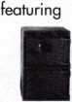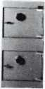

We ship your order within

24 hours

See us

*at* [*www.a-bsafecorp.com*](http://www.a-bsafecorp.com)800-253-1267  
Fox 856-863-1208

CALL FOR YOUR  
CATALOG TODAY

Keynotes • February 2003

**back page**

About the Authors

Claire Cohen, the second woman to become a CML, has been in locksmithing since 1977, and has been writing articles for Keynotes since 1987. She is also a contributing editor for Keynotes, and received the 2001 Keynotes Author of the Year Award - again, only the second woman to achieve that honor.

Sal Dulcamaro, CML, has been in the security industry for over 27 years. He is the president of All Pro Security, Inc. in Michigan and has been an ALOA member for 20 years. A past president of the Locksmith Security Association of Michigan, Sal currently serves as web editor of the association's on-line newsletter. He was named Keynotes "Author of the Year" in both 1996 and 1997. He is also a contributing editor for Keynotes. Find Sal on the Internet at: <http://www.home.earthlink.net/~lockwriter>

Billy Edwards, CML is known for his expertise in Master Keying. Mr. Edwards has held the position of Key Records Manager with Medeco Security Locks, Yale Security, ASSA Inc., Abloy Inc., Arrow Lock Company and Master Lock Co. where he is currently employed. He has been a locksmith since 1969 and started as an in-house locksmith for the University of Louisville, Ky. He has been a Contributing Editor and an Editorial advisor to Keynotes in the past and was a Technical Editor for the Reed Security Reporter. His book "Master Keying by the Numbers" is in its second printing and available from Security Resources Inc. He is also a charter member of, and current Chairman of, the Lock Industry Standards and Training (LIST) Council. He has taught factory certification classes for all of his employers, mas­ter keying classes and basic locksmithing and picking classes throughout the US. He is a member of IAIL, an honorary mem­ber of CSLA and MLANJ, a 29 year member of ALOA as well as a charter member of the Clearstar Security Network. In 1988 he was the recipient of the coveted Philadelphia Award.

Greg Perry, CML, CPS, has been in the locksmith industry for 2G years. He's spent half of that time as a field technician for Security Engineering in Ridgecrest, CA. Greg is also a past pres­ident of the Desert Counties Chapter of the California Locksmiths Association. He has also won the 2002 Keynotes Author of the Year Award. You can e-mail him at [glmperry@iwvisp.com](mailto:glmperry@iwvisp.com).

Jeff Trepanier, RL, owns and operates Interstate Lock Masters in Racine, Wl. He has been published in several trade magazines and is widely recognized as an automotive locksmithing guru.

TURn IQ

**WHOLESALE SERVICE**

In-Stock... SAFES FREE Freight Program Fax: 800-391-4553

800**-**848-9790

AMSEC FireKing Gaidall HAYMAN MEILINK \/lCTOR

**r**

Sanzo Specialties 1

Kaba Mas 7

Fox Valley

Technical College 9

A&B Safe Corp 19, 43

Jameson Code Svc 25

CollectAChek 27

Videx 35

Lockmasters 37

MLANJ 41

Turn 10 Back Page

Safetech Inside Back Cover Hickok Back Cover

**Ad Index**

L.

j

Keynotes • February 2003

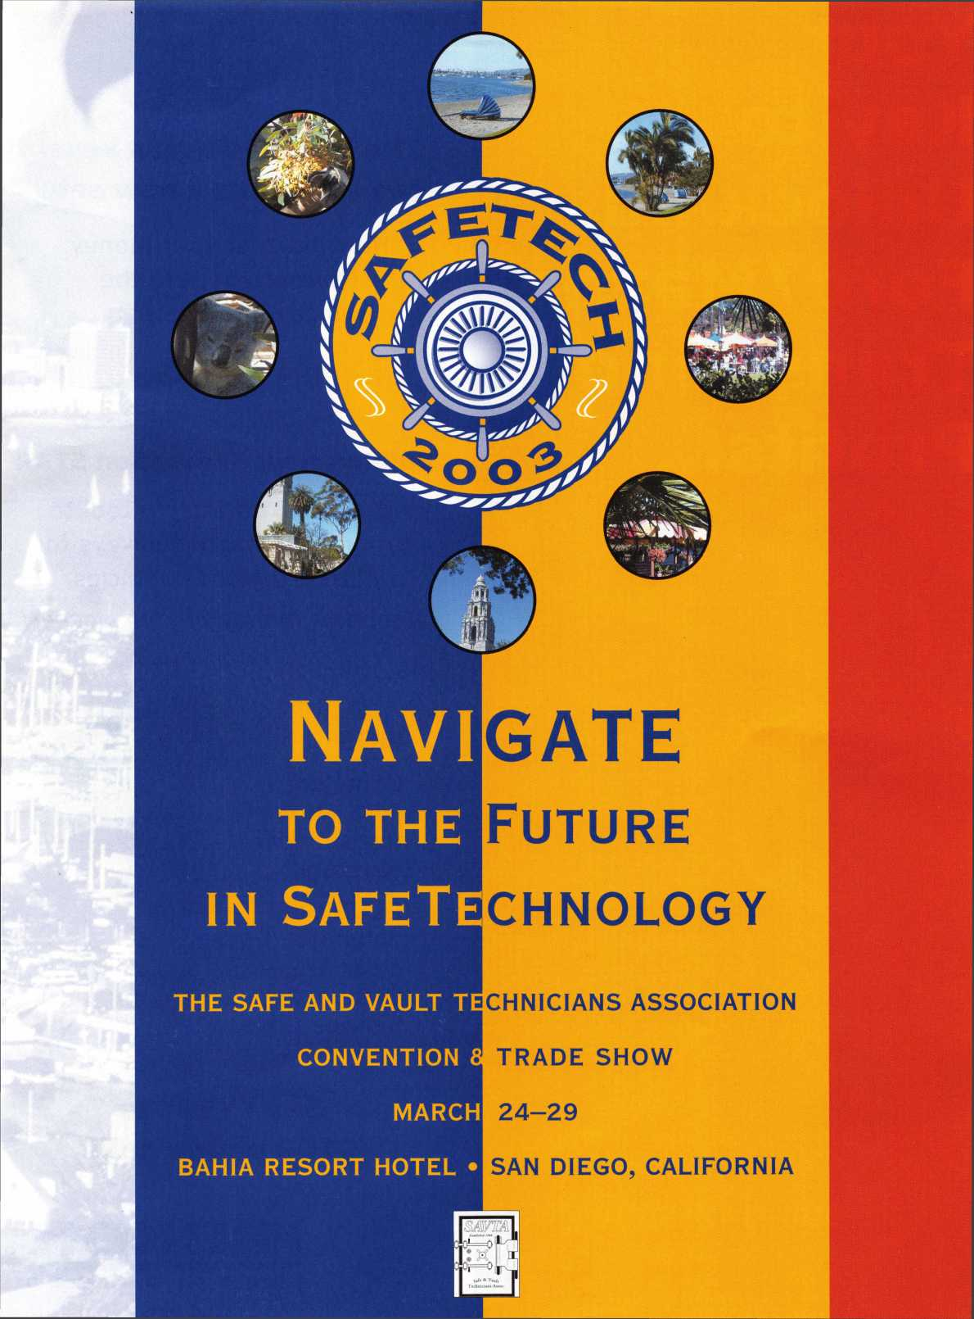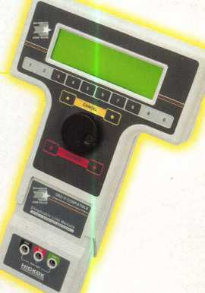

I've lost my Taurus

can you make a new

How much of your money

have you sent to the  
local Ford dealer?

8008LA New Generation STAR

Use the Ford factory tool to  
program transponder keys for  
ALL Ford/Mazda vehicles.

Keep the money in your pocket!

Say "YES" to  
$100 phone calls

NGS

Complete

Ford/Mazda

transponder

coverage

PLUS the

ability to clear ALL

Diagnostic

Service Codes

